UNITED STATES
SECURITIES AND EXCHANGE COMMISSION
Washington, D.C. 20549

FORM 8-K

CURRENT REPORT

Pursuant to Section 13 OR 15(d) of the
Securities Exchange Act of 1934

Date of Report (Date of earliest event reported): January 26, 2022

META FINANCIAL GROUP, INC.
(Exact name of registrant as specified in its charter)

Delaware |  |  | 0-22140 |  |  | 42-1406262
(State or other jurisdiction of incorporation) |  |  | (Commission File Number) |  |  | (IRS Employer Identification No.)

5501 South Broadband Lane, Sioux Falls, South Dakota 57108
(Address of principal executive offices) (Zip Code)

Registrant’s telephone number, including area code: (877) 497-7497

Check the appropriate box below if the Form 8-K filing is intended to simultaneously satisfy the filing obligation of the registrant under any of the following provisions:
☐ |  |  | Written communications pursuant to Rule 425 under the Securities Act (17 CFR 230.425)
☐ |  |  | Soliciting material pursuant to Rule 14a-12 under the Exchange Act (17 CFR 240.14a-12)
☐ |  |  | Pre-commencement communications pursuant to Rule 14d-2(b) under the Exchange Act (17 CFR 240.14d- 2(b))
☐ |  |  | Pre-commencement communications pursuant to Rule 13e-4(c) under the Exchange Act (17 CFR 240.13e-4 (c))

Securities registered pursuant to Section 12(b) of the Act:
Title of each class |  |  | Trading Symbol(s) |  |  | Name of each exchange on which registered
Common Stock, $.01 par value |  |  | CASH |  |  | The NASDAQ Stock Market LLC

Indicate by check mark whether the registrant is an emerging growth company as defined in Rule 405 of the Securities Act of 1933 (§230.405 of this chapter) or Rule 12b-2 of the Securities Exchange Act of 1934 (§240.12b-2 of this chapter).
Emerging growth company ☐

If an emerging growth company, indicate by check mark if the registrant has elected not to use the extended transition period for complying with any new or revised financial accounting standards provided pursuant to Section 13(a) of the Exchange Act. ☐

Item 2.02 Results of Operations and Financial Condition.

On January 26, 2022, the Registrant issued a press release announcing its results of operations and financial condition as of and for the three months ended December 31, 2021. A copy of the press release is attached as Exhibit 99.1 to this report and is incorporated into this Item 2.02 by reference.

The information in this Item 2.02, including Exhibit 99.1, shall not be deemed to be “filed” for purposes of Section 18 of the Securities Exchange Act of 1934, as amended (the “Exchange Act”), or otherwise subject to the liabilities thereof, nor shall it be deemed to be incorporated by reference in any filing under the Exchange Act or under the Securities Act of 1933, as amended (the "Securities Act"), except to the extent specifically provided in any such filing.

Item 7.01 Regulation FD Disclosure.

Information is being furnished herein in Exhibit 99.2 with respect to the Investor Update slide presentation prepared for use with the press release. While most of the selected financial information furnished herein is derived from the Company’s consolidated financial statements and related notes prepared in accordance with generally accepted accounting principles ("GAAP") and management’s discussion and analysis of financial condition and results of operations included, or to be included, in the Company’s reports on Forms 10-K and 10-Q, this information includes selected financial and operational information through the first quarter of fiscal year 2022 and does not represent a complete set of financial statement and related notes prepared in conformity with GAAP. The Company’s annual financial statements are subject to independent audit. The Investor Update slide presentation is dated January 26, 2022 and the Company does not undertake to update the materials after that date.

The information in this Item 7.01, including Exhibit 99.2, shall not be deemed to be “filed” for purposes of Section 18 of the Exchange Act, or otherwise subject to the liabilities thereof, nor shall it be deemed to be incorporated by reference in any filing under the Exchange Act or under the Securities Act, except to the extent specifically provided in any such filing.

Item 9.01 Financial Statements and Exhibits.

(d) Exhibits
Exhibit Number |  |  |  |  |  | Description of Exhibit
99.1 |  |  |  |  |  | Press Release of Meta Financial Group, Inc., dated January 26, 2022 regarding the results of operations and financial condition.
99.2 |  |  |  |  |  | Investor Update slide presentation for the First Quarter of Fiscal Year 2022, dated January 26, 2022, prepared for use with the Press Release.
104 |  |  |  |  |  | Cover Page Interactive Data File (embedded within the Inline XBRL document)

SIGNATURE
Pursuant to the requirements of the Securities Exchange Act of 1934, the Registrant has duly caused this report to be signed on its behalf by the undersigned hereunto duly authorized.

 |  |  |  |  |  | META FINANCIAL GROUP, INC.
Date: January 26, 2022 |  |  | By: |  |  | /s/ Glen W. Herrick
 |  |  |  |  |  | Glen W. Herrick
 |  |  |  |  |  | Executive Vice President and Chief Financial Officer

Exhibit 99.1

META FINANCIAL GROUP, INC.® ANNOUNCES RESULTS FOR 2022 FISCAL FIRST QUARTER
- Fiscal 2022 First Quarter Net Income of $61.3 million, or $2.00 Per Diluted Share -
- Rebranding Process Underway Following Agreement to Sell Meta Names and Trademarks -
- Completes Sale of Remaining Community Bank Loans -
Sioux Falls, S.D., January 26, 2022 -- Meta Financial Group, Inc.® (Nasdaq: CASH) (“Meta” or the “Company”) reported net income of $61.3 million, or $2.00 per share, for the three months ended December 31, 2021, compared to net income of $28.0 million, or $0.84 per share, for the three months ended December 31, 2020. During the fiscal first quarter of 2022, the Company recognized a gain on sale of Meta names and trademarks of $50.0 million. Excluding the impact of the gain on sale of these assets, the Company's adjusted net income for the quarter totaled $23.9 million, or $0.78 per share. See non-GAAP reconciliation table below.
"We made continued progress towards our three strategic initiatives, as reflected in our strong fiscal first quarter results,” said CEO Brett Pharr. “We generated growth in earnings per share while positioning the Company for future growth through two significant strategic transactions during the first quarter.”
“Following the initiation of a comprehensive brand strategy review earlier in calendar 2021, we announced our agreement to sell the Meta name and trademarks to Beige Key LLC. This transaction provides significant funds, allowing us to advance a new corporate name and brand that represent our significant evolution and better enable us to fulfill our vision of “Financial Inclusion for All®,” Pharr noted.
Executive Vice President and CFO Glen Herrick added, “We are also pleased to have sold our remaining legacy community bank loans, completing the wind-down of that portfolio and marking another critical step in optimizing our interest-earning asset mix. Coupled with our strong financial results, our momentum continues to build, giving us confidence in our positive outlook and growth trajectory.”

Business Development Highlights for the 2022 Fiscal First Quarter
•Entered into an agreement with Beige Key LLC to sell the Meta names and trademarks for $60 million, of which $50 million was recognized as noninterest income in the first fiscal quarter. The Company plans to use a portion of the proceeds to implement its new corporate name and brand, which is expected to be completed by the end of 2022, and estimates its rebranding expenses will range between $15 million to $20 million. The remainder of the proceeds will be used for general corporate purposes including tax-efficient capital allocation.
•Sold all remaining $192.5 million of community banking loans, reducing this portfolio to zero and generating a favorable pre-tax impact of approximately $3.9 million after netting the recovery of provision expense from the portfolio's $12.3 million allowance and the loss on sale of loans of $8.4 million.
•Extended the agreement with Emerald Financial Services, LLC, a wholly-owned, indirect subsidiary of H&R Block, through June 30, 2025. The agreement adds valuable new financial product offerings and capabilities for customers, including Spruce Accounts, a mobile banking platform that features a spending account with an attached debit card. This innovative product, designed to help a consumer better manage their financial resources and meet spending goals, is powered by MetaBank.
•Originated $21.2 million in aggregate principal of renewable energy loan financing for the first quarter of fiscal 2022, resulting in $5.7 million in total net investment tax credits.

1

•Repurchased 1,711,501 shares, at an average price of $58.97, in the first fiscal quarter. The company purchased an additional 130,000 shares through January 20, 2022 at an average share price of $61.26 and has 5,474,375 shares available for repurchase under the common stock share repurchase program announced during the fourth quarter of fiscal year 2021.
Financial Highlights for the 2022 Fiscal First Quarter
•Total revenue for the first quarter was $158.2 million, an increase of $46.7 million, or 42%, compared to the same quarter in fiscal 2021, primarily driven by the gain on sale of the Meta names and trademarks.
•Net interest income for the first quarter was $71.6 million, an increase of $5.6 million compared to $66.0 million in the first quarter last year.
•Net interest margin ("NIM") was essentially unchanged, declining to 4.59% for the first quarter from 4.65% during the same period of last year. The increase in higher-yielding loans and leases was offset by an increase in lower-yielding investment securities balances and the continued low interest rate environment.
•Total gross loans and leases at December 31, 2021 increased $243.0 million, to $3.68 billion, or 7%, compared to December 31, 2020 and increased $74.8 million, or 2%, when compared to September 30, 2021. The increase was driven by growth across our loan portfolios, partially offset by the sale of all remaining community banking loans during the quarter.

Net Interest Income
Net interest income for the first quarter of fiscal 2022 was $71.6 million, an increase of 9% from the same quarter in fiscal 2021. The increase was mainly attributable to an improved earning asset and liability mix, along with increased loan balances.
The first quarter average outstanding balance of loans and leases increased $211.3 million compared to the same quarter of the prior year, primarily due to increases in our core loan and lease portfolios, partially offset by the sale of the remaining community bank portfolio. The Company’s average interest-earning assets for the first quarter increased by $547.2 million to $6.18 billion compared with the same quarter in fiscal 2021, primarily due to growth in total investments and total loans and leases.
Fiscal 2022 first quarter NIM decreased to 4.59% from 4.65% in the first quarter of last year. The overall reported tax-equivalent yield (“TEY”) on average earning asset yields decreased 13 basis points to 4.69% compared to the prior year quarter, primarily driven by an increase in lower-yielding investment securities balances of $561.4 million. The TEY on the securities portfolio was 1.58% compared to 1.79% for the comparable period last year.
The Company's cost of funds for all deposits and borrowings averaged 0.08% during the fiscal 2022 first quarter, compared to 0.15% during the prior year quarter, primarily driven by a reduction in wholesale deposit balances along with an increase in noninterest bearing deposits. The Company's overall cost of deposits was 0.01% in the fiscal first quarter of 2022, compared to 0.06% in the same quarter last year.

Noninterest Income
Fiscal 2022 first quarter noninterest income increased to $86.6 million, compared to $45.5 million for the same period of the prior year. The significant increase was driven by the $50 million gain on sale of the Meta names and trademarks and to a lesser extent an increase in payments fee income and rental income.
The Company also recognized a loss on sale of other during the quarter of $3.5 million, a $6.3 million decrease from the prior year period, primarily consisting of a $8.4 million loss attributable to the sale of the remaining community bank loans partially offset by a $3.4 million gain on sale of SBA loans.
Also partially offsetting the increase during the quarter was a decrease in other income, which includes a net unrealized loss of $3.3 million on a prior investment in MoneyLion Inc. This loss partially offsets a net unrealized gain of $4.1 million recognized by the Company during the fourth quarter of fiscal 2021 following the completion of MoneyLion's de-SPAC process and listing on the New York Stock Exchange on September 22, 2021.

2

Noninterest Expense
Noninterest expense increased 14% to $82.4 million for the fiscal 2022 first quarter, from $72.6 million for the same quarter last year. The increase in expense was primarily driven by an increase in compensation expense, other expense, occupancy and equipment expense, and card processing expense. When comparing the fiscal 2022 first quarter to the fourth quarter of 2021, non-interest expense decreased by $11.2 million.
Income Tax Expense
The Company recorded income tax expense of $14.3 million, representing an effective tax rate of 18.9%, for the fiscal 2022 first quarter, compared to $3.5 million, representing an effective tax rate of 10.8%, for the first quarter last year. The increase in income tax expense was primarily due to increased earnings.
The Company originated $21.2 million in solar leases during the fiscal 2022 first quarter, compared to $38.5 million in last year's first quarter. Investment tax credits related to solar leases are recognized ratably based on income throughout each fiscal year. The timing and impact of future solar tax credits are expected to vary from period to period, and Meta intends to undertake only those tax credit opportunities that meet the Company's underwriting and return criteria.

Investments, Loans and Leases
 |  |  | December 31, 2021 |  |  |  |  |  | September 30, 2021 |  |  |  |  |  | June 30, 2021 |  |  |  |  |  | March 31, 2021 |  |  |  |  |  | December 31, 2020
Total investments |  |  | $ | 1,833,733 |  |  |  |  | $ | 1,921,568 |  |  |  |  | $ | 1,981,852 |  |  |  |  | $ | 1,552,892 |  |  |  |  | $ | 1,309,452
Loans held for sale
Consumer credit products |  |  | 20,728 |  |  |  |  |  | 23,111 |  |  |  |  |  | 12,582 |  |  |  |  |  | 6,233 |  |  |  |  |  | 234
SBA/USDA |  |  | 15,454 |  |  |  |  |  | 33,083 |  |  |  |  |  | 57,208 |  |  |  |  |  | 61,402 |  |  |  |  |  | 32,983
Community Bank |  |  | — |  |  |  |  |  | — |  |  |  |  |  | 18,115 |  |  |  |  |  | — |  |  |  |  |  | 100,442
Total loans held for sale |  |  | 36,182 |  |  |  |  |  | 56,194 |  |  |  |  |  | 87,905 |  |  |  |  |  | 67,635 |  |  |  |  |  | 133,659
Term lending |  |  | 1,038,378 |  |  |  |  |  | 961,019 |  |  |  |  |  | 920,279 |  |  |  |  |  | 891,414 |  |  |  |  |  | 881,306
Asset based lending |  |  | 337,236 |  |  |  |  |  | 300,225 |  |  |  |  |  | 263,237 |  |  |  |  |  | 248,735 |  |  |  |  |  | 242,298
Factoring |  |  | 402,972 |  |  |  |  |  | 363,670 |  |  |  |  |  | 320,629 |  |  |  |  |  | 277,612 |  |  |  |  |  | 275,650
Lease financing |  |  | 245,315 |  |  |  |  |  | 266,050 |  |  |  |  |  | 282,940 |  |  |  |  |  | 308,169 |  |  |  |  |  | 283,722
Insurance premium finance |  |  | 385,473 |  |  |  |  |  | 428,867 |  |  |  |  |  | 417,652 |  |  |  |  |  | 344,841 |  |  |  |  |  | 338,227
SBA/USDA |  |  | 209,521 |  |  |  |  |  | 247,756 |  |  |  |  |  | 263,709 |  |  |  |  |  | 331,917 |  |  |  |  |  | 300,707
Other commercial finance |  |  | 178,853 |  |  |  |  |  | 157,908 |  |  |  |  |  | 118,081 |  |  |  |  |  | 103,234 |  |  |  |  |  | 101,209
Commercial Finance |  |  | 2,797,748 |  |  |  |  |  | 2,725,495 |  |  |  |  |  | 2,586,527 |  |  |  |  |  | 2,505,922 |  |  |  |  |  | 2,423,119
Consumer credit products |  |  | 173,343 |  |  |  |  |  | 129,251 |  |  |  |  |  | 105,440 |  |  |  |  |  | 104,842 |  |  |  |  |  | 88,595
Other consumer finance |  |  | 144,412 |  |  |  |  |  | 123,606 |  |  |  |  |  | 122,316 |  |  |  |  |  | 130,822 |  |  |  |  |  | 162,423
Consumer Finance |  |  | 317,755 |  |  |  |  |  | 252,857 |  |  |  |  |  | 227,756 |  |  |  |  |  | 235,664 |  |  |  |  |  | 251,018
Tax Services |  |  | 100,272 |  |  |  |  |  | 10,405 |  |  |  |  |  | 41,268 |  |  |  |  |  | 225,921 |  |  |  |  |  | 92,548
Warehouse Finance |  |  | 466,831 |  |  |  |  |  | 419,926 |  |  |  |  |  | 335,704 |  |  |  |  |  | 332,456 |  |  |  |  |  | 318,937
Community Banking |  |  | — |  |  |  |  |  | 199,132 |  |  |  |  |  | 303,984 |  |  |  |  |  | 348,065 |  |  |  |  |  | 353,942
Total gross loans and leases |  |  | 3,682,606 |  |  |  |  |  | 3,607,815 |  |  |  |  |  | 3,495,239 |  |  |  |  |  | 3,648,028 |  |  |  |  |  | 3,439,564
Allowance for credit losses |  |  | (67,623) |  |  |  |  |  | (68,281) |  |  |  |  |  | (91,208) |  |  |  |  |  | (98,892) |  |  |  |  |  | (72,389)
Net deferred loan and lease origination fees |  |  | 1,655 |  |  |  |  |  | 1,748 |  |  |  |  |  | 1,431 |  |  |  |  |  | 9,503 |  |  |  |  |  | 9,111
Total loans and leases, net of allowance |  |  | $ | 3,616,638 |  |  |  |  | $ | 3,541,282 |  |  |  |  | $ | 3,405,462 |  |  |  |  | $ | 3,558,639 |  |  |  |  | $ | 3,376,286

The Company's investment security balances at December 31, 2021 totaled $1.83 billion, as compared to $1.92 billion at September 30, 2021 and $1.31 billion at December 31, 2020.
Total gross loans and leases totaled $3.68 billion at December 31, 2021, as compared to $3.61 billion at September 30, 2021 and $3.44 billion and as compared to December 31, 2020. The primary drivers for the increase on a linked quarter basis were tax services, commercial finance, consumer credit, and warehouse finance loans, partially offset by the sale of all remaining community bank loans.
3

Commercial finance loans, which comprised 76% of the Company's gross loan and lease portfolio, totaled $2.80 billion at December 31, 2021, reflecting growth of $72.3 million, or 3%, from September 30, 2021 and $374.6 million, or 15%, from December 31, 2020.
As of December 31, 2021, the Company had 275 loans outstanding with total loan balances of $63.8 million originated as part of the Paycheck Protection Program ("PPP"), compared with 370 loans outstanding with total loan balances of $96.0 million for the quarter ended September 30, 2021. In total, approximately 80% of the PPP loan balances were forgiven through December 31, 2021.
During the first fiscal quarter of 2022, the Company sold all remaining community banking loans. The outstanding balance of community banking loans at September 30, 2021 and December 31, 2020 was $199.1 million and $353.9 million, respectively. The amount of community banking loans sold during the quarter totaled $192.5 million.
Asset Quality
The Company’s allowance for credit losses ("ACL") totaled $67.6 million at December 31, 2021, a decrease compared to $68.3 million at September 30, 2021 and $72.4 million at December 31, 2020. The reduction in the ACL at December 31, 2021, when compared to September 30, 2021, was primarily due to a $12.3 million decrease attributable to the community banking portfolio, as all loans have now been sold. This decrease was partially offset by increases within commercial finance of $8.7 million, tax services of $1.6 million, and consumer finance of $1.2 million.
The $4.8 million year-over-year decrease in the ACL was primarily driven by a $14.2 million decrease attributable to the community banking portfolio, due to pay downs and the aforementioned loan sales, along with a $2.4 million decrease in the consumer finance portfolio. These decreases were partially offset by a $11.5 million increase within the commercial finance portfolio, and to a lesser extent, increases within the tax services and warehouse finance portfolios.
The following table presents the Company's ACL as a percentage of its total loans and leases.

 |  |  | As of the Period Ended
(Unaudited) |  |  | December 31, 2021 |  |  | September 30, 2021 |  |  | June 30, 2021 |  |  | March 31, 2021 |  |  | December 31, 2020
Commercial finance |  |  | 2.04 |  | % | 1.77 |  | % | 1.73 |  | % | 1.77 |  | % | 1.88 |  | %
Consumer finance |  |  | 2.70 |  | % | 2.91 |  | % | 3.80 |  | % | 4.70 |  | % | 4.39 |  | %
Tax services |  |  | 1.60 |  | % | 0.02 |  | % | 58.99 |  | % | 12.90 |  | % | 1.53 |  | %
Warehouse finance |  |  | 0.10 |  | % | 0.10 |  | % | 0.10 |  | % | 0.10 |  | % | 0.10 |  | %
Community bank |  |  | — |  | % | 6.16 |  | % | 4.36 |  | % | 4.03 |  | % | 4.01 |  | %
Total loans and leases |  |  | 1.84 |  | % | 1.89 |  | % | 2.61 |  | % | 2.71 |  | % | 2.10 |  | %

The Company's ACL as a percentage of total loans and leases decreased to 1.84% at December 31, 2021 from 1.89% at September 30, 2021. The decrease in the total loans and leases coverage ratio reflected the release of the community banking portfolio allowance. The coverage ratio for the commercial finance portfolio increased compared to the September 30, 2021 quarter due to specific reserves on two individually evaluated loan relationships. The consumer finance coverage ratio decreased primarily due to an improved overall macroeconomic outlook while the tax services coverage increased due to the seasonal start of tax season, similar to the same period of the prior year. The Company expects to continue to diligently monitor the ACL and adjust as necessary in future periods to maintain an appropriate and supportable level.
4

Activity in the allowance for credit losses for the periods presented was as follows.

(Unaudited) |  |  | Three Months Ended
 |  |  | December 31, 2021 |  |  | September 30, 2021 |  |  | December 31, 2020
(Dollars in thousands)
Beginning balance |  |  | $ | 68,281 |  | $ | 91,208 |  | $ | 56,188
Adoption of CECL accounting standard |  |  | — |  |  | — |  |  | 12,773
(Reversal of) provision - tax services loans |  |  | (714) |  |  | 457 |  |  | 454
Provision - all other loans and leases |  |  | 1,184 |  |  | 8,368 |  |  | 5,810
Charge-offs - tax services loans |  |  | (254) |  |  | (24,849) |  |  | —
Charge-offs - all other loans and leases |  |  | (4,605) |  |  | (7,635) |  |  | (5,675)
Recoveries - tax services loans |  |  | 2,567 |  |  | 51 |  |  | 956
Recoveries - all other loans and leases |  |  | 1,164 |  |  | 681 |  |  | 1,883
Ending balance |  |  | $ | 67,623 |  | $ | 68,281 |  | $ | 72,389
The Company recognized a provision for credit losses of $0.2 million for the quarter ended December 31, 2021, compared to $6.1 million for the comparable period in the prior fiscal year. Net charge-offs were $1.1 million for the quarter ended December 31, 2021, compared to $2.8 million for the quarter ended December 31, 2020. Net charge-offs attributable to the commercial finance portfolio for the quarter were $3.2 million, partially offset by net recoveries from the tax services portfolio of $2.3 million.
The Company's past due loans and leases were as follows for the periods presented.

As of December 31, 2021 |  |  | Accruing and Nonaccruing Loans and Leases |  |  |  |  |  |  |  |  |  |  |  |  |  |  |  |  |  |  |  |  |  |  |  |  |  |  |  |  |  |  |  |  |  |  |  | Nonperforming Loans and Leases
(Dollars in Thousands) |  |  | 30-59 Days  Past Due |  |  |  |  |  | 60-89 Days  Past Due |  |  |  |  |  | > 89 Days Past Due |  |  |  |  |  | Total Past  Due |  |  |  |  |  | Current |  |  |  |  |  | Total Loans and Leases  Receivable |  |  |  |  |  | > 89 Days Past Due and Accruing |  |  |  |  |  | Non-accrual balance |  |  |  |  |  | Total
Loans held for sale |  |  | $ | 9 |  |  |  |  | $ | 2 |  |  |  |  | $ | — |  |  |  |  | $ | 11 |  |  |  |  | $ | 36,171 |  |  |  |  | $ | 36,182 |  |  |  |  | $ | — |  |  |  |  | $ | — |  |  |  |  | $ | —
Commercial finance |  |  | $ | 41,473 |  |  |  |  | $ | 8,539 |  |  |  |  | $ | 7,568 |  |  |  |  | $ | 57,580 |  |  |  |  | $ | 2,740,168 |  |  |  |  | $ | 2,797,748 |  |  |  |  | $ | 3,896 |  |  |  |  | $ | 37,760 |  |  |  |  | $ | 41,656
Consumer finance |  |  | 4,880 |  |  |  |  |  | 2,277 |  |  |  |  |  | 1,534 |  |  |  |  |  | 8,691 |  |  |  |  |  | 309,064 |  |  |  |  |  | 317,755 |  |  |  |  |  | 1,534 |  |  |  |  |  | — |  |  |  |  |  | 1,534
Tax services |  |  | — |  |  |  |  |  | — |  |  |  |  |  | — |  |  |  |  |  | — |  |  |  |  |  | 100,272 |  |  |  |  |  | 100,272 |  |  |  |  |  | — |  |  |  |  |  | — |  |  |  |  |  | —
Warehouse finance |  |  | — |  |  |  |  |  | — |  |  |  |  |  | — |  |  |  |  |  | — |  |  |  |  |  | 466,831 |  |  |  |  |  | 466,831 |  |  |  |  |  | — |  |  |  |  |  | — |  |  |  |  |  | —
Total loans and leases held for investment |  |  | 46,353 |  |  |  |  |  | 10,816 |  |  |  |  |  | 9,102 |  |  |  |  |  | 66,271 |  |  |  |  |  | 3,616,335 |  |  |  |  |  | 3,682,606 |  |  |  |  |  | 5,430 |  |  |  |  |  | 37,760 |  |  |  |  |  | 43,190
Total loans and leases |  |  | 46,362 |  |  |  |  |  | 10,818 |  |  |  |  |  | 9,102 |  |  |  |  |  | 66,282 |  |  |  |  |  | 3,652,506 |  |  |  |  |  | 3,718,788 |  |  |  |  |  | 5,430 |  |  |  |  |  | 37,760 |  |  |  |  |  | 43,190

As of September 30, 2021 |  |  | Accruing and Nonaccruing Loans and Leases |  |  |  |  |  |  |  |  |  |  |  |  |  |  |  |  |  |  |  |  |  |  |  |  |  |  |  |  |  |  |  |  |  |  |  | Nonperforming Loans and Leases
(Dollars in Thousands) |  |  | 30-59 Days Past Due |  |  |  |  |  | 60-89 Days Past Due |  |  |  |  |  | > 89 Days Past Due |  |  |  |  |  | Total Past Due |  |  |  |  |  | Current |  |  |  |  |  | Total Loans and Leases Receivable |  |  |  |  |  | > 89 Days Past Due and Accruing |  |  |  |  |  | Non-accrual balance |  |  |  |  |  | Total
Commercial finance |  |  | $ | 18,269 |  |  |  |  | $ | 7,388 |  |  |  |  | $ | 15,439 |  |  |  |  | $ | 41,096 |  |  |  |  | $ | 2,684,399 |  |  |  |  | $ | 2,725,495 |  |  |  |  | $ | 12,489 |  |  |  |  | $ | 19,330 |  |  |  |  | $ | 31,819
Consumer finance |  |  | 1,676 |  |  |  |  |  | 812 |  |  |  |  |  | 1,236 |  |  |  |  |  | 3,724 |  |  |  |  |  | 249,133 |  |  |  |  |  | 252,857 |  |  |  |  |  | 1,236 |  |  |  |  |  | — |  |  |  |  |  | 1,236
Tax services |  |  | — |  |  |  |  |  | — |  |  |  |  |  | 7,962 |  |  |  |  |  | 7,962 |  |  |  |  |  | 2,443 |  |  |  |  |  | 10,405 |  |  |  |  |  | 7,962 |  |  |  |  |  | — |  |  |  |  |  | 7,962
Warehouse finance |  |  | — |  |  |  |  |  | — |  |  |  |  |  | — |  |  |  |  |  | — |  |  |  |  |  | 419,926 |  |  |  |  |  | 419,926 |  |  |  |  |  | — |  |  |  |  |  | — |  |  |  |  |  | —
Community banking |  |  | — |  |  |  |  |  | — |  |  |  |  |  | — |  |  |  |  |  | — |  |  |  |  |  | 199,132 |  |  |  |  |  | 199,132 |  |  |  |  |  | — |  |  |  |  |  | 14,915 |  |  |  |  |  | 14,915
Total loans and leases held for investment |  |  | 19,945 |  |  |  |  |  | 8,200 |  |  |  |  |  | 24,637 |  |  |  |  |  | 52,782 |  |  |  |  |  | 3,555,033 |  |  |  |  |  | 3,607,815 |  |  |  |  |  | 21,687 |  |  |  |  |  | 34,245 |  |  |  |  |  | 55,932

5

The Company's nonperforming assets at December 31, 2021 were $44.3 million, representing 0.58% of total assets, compared to $61.8 million, or 0.92% of total assets at September 30, 2021 and $53.2 million, or 0.73% of total assets at December 31, 2020. The changes in the nonperforming assets as a percentage of total assets at December 31, 2021 were driven in large part by a decrease in nonperforming assets in the community bank and tax services portfolios, partially offset by an increase in nonperforming assets in the commercial finance portfolio, when compared to the linked-quarter. When comparing the current period to the same period of the prior year, the decrease in nonperforming assets was due to a decrease in nonperforming assets in the community bank portfolio, partially offset by an increase in nonperforming assets in the commercial finance portfolio.
The Company's nonperforming loans and leases at December 31, 2021, were $43.2 million, representing 1.16% of total gross loans and leases, compared to $55.9 million, or 1.52% of total gross loans and leases at September 30, 2021 and $43.5 million, or 1.17% of total gross loans and leases at December 31, 2020. The decreases are related to the aforementioned decreases in nonperforming assets in the community bank and tax services portfolios, partially offset by an increase in nonperforming assets in the commercial finance portfolio.
The Company has various portfolios of consumer lending and tax services loans that present unique risks that are statistically managed. Due to the unique risks associated with these portfolios, the Company monitors other credit quality indicators in their evaluation of the appropriateness of the allowance for credit losses on these portfolios, and as such, these loans are not included in the asset classification table below. The Company's loans and leases held for investment by asset classification were as follows for the periods presented.

Asset Classification |  |  | Pass |  |  | Watch |  |  | Special Mention |  |  | Substandard |  |  | Doubtful |  |  | Total
As of December 31, 2021 |  |  | (Dollars in Thousands)
Commercial finance |  |  | $ | 2,084,835 |  | $ | 355,431 |  | $ | 161,301 |  | $ | 176,258 |  | $ | 19,923 |  | $ | 2,797,748
Warehouse finance |  |  | 466,831 |  |  | — |  |  | — |  |  | — |  |  | — |  |  | 466,831
Total Loans and Leases |  |  | $ | 2,551,666 |  | $ | 355,431 |  | $ | 161,301 |  | $ | 176,258 |  | $ | 19,923 |  | $ | 3,264,579

Asset Classification |  |  | Pass |  |  | Watch |  |  | Special Mention |  |  | Substandard |  |  | Doubtful |  |  | Total
As of September 30, 2021 |  |  | (Dollars in Thousands)
Commercial finance |  |  | $ | 2,039,324 |  | $ | 364,713 |  | $ | 170,527 |  | $ | 144,414 |  | $ | 6,517 |  | $ | 2,725,495
Warehouse finance |  |  | 419,926 |  |  | — |  |  | — |  |  | — |  |  | — |  |  | 419,926
Community banking |  |  | 10,314 |  |  | 27,121 |  |  | 35,916 |  |  | 120,238 |  |  | 5,543 |  |  | 199,132
Total Loans and Leases |  |  | $ | 2,469,564 |  | $ | 391,834 |  | $ | 206,443 |  | $ | 264,652 |  | $ | 12,060 |  | $ | 3,344,553

Deposits, Borrowings and Other Liabilities
Total average deposits for the fiscal 2022 first quarter increased by $494.9 million to $5.92 billion compared to the same period in fiscal 2021, primarily due to an increase in noninterest-bearing deposits of $808.2 million. Average wholesale deposits decreased $193.8 million for the fiscal 2022 first quarter when compared to the same period in fiscal 2021.
The average balance of total deposits and interest-bearing liabilities was $6.01 billion for the three-month period ended December 31, 2021, compared to $5.52 billion for the same period in the prior fiscal year, representing an increase of 9%.
Total end-of-period deposits increased 5% to $6.53 billion at December 31, 2021, compared to $6.21 billion at December 31, 2020. The increase in end-of-period deposits was primarily driven by an increase in noninterest-bearing deposits of $688.0 million, partially offset by a decrease in wholesale deposits of $161.2 million. The increase in noninterest-bearing deposits was driven by government stimulus-related dollars loaded on various partner cards.

6

Of the 16.5 million prepaid cards issued in conjunction with the three EIP stimulus programs, totaling approximately $24.15 billion, $1.38 billion were outstanding as of December 31, 2021, of which only $28.1 million was on Meta’s balance sheet with the remainder being held by other banks.

Regulatory Capital
The Company and MetaBank remained above the federal regulatory minimum capital requirements at December 31, 2021, continued to be classified as well-capitalized, and in good standing with the regulatory agencies. Regulatory capital ratios of the Company and the Bank are stated in the table below.
The tables below include certain non-GAAP financial measures that are used by investors, analysts and bank regulatory agencies to assess the capital position of financial services companies. Management reviews these measures along with other measures of capital as part of its financial analysis.

As of the dates indicated |  |  | December 31, 2021 (1) |  |  |  |  |  | September 30,  2021 |  |  |  |  |  | June 30,  2021 |  |  |  |  |  | March 31,  2021 |  |  |  |  |  | December 31,  2020
Company
Tier 1 leverage capital ratio |  |  | 7.39 |  | % |  |  |  | 7.67 |  | % |  |  |  | 6.85 |  | % |  |  |  | 4.75 |  | % |  |  |  | 7.39 |  | %
Common equity Tier 1 capital ratio |  |  | 10.88 |  | % |  |  |  | 12.12 |  | % |  |  |  | 12.76 |  | % |  |  |  | 11.29 |  | % |  |  |  | 10.72 |  | %
Tier 1 capital ratio |  |  | 11.20 |  | % |  |  |  | 12.46 |  | % |  |  |  | 13.11 |  | % |  |  |  | 11.63 |  | % |  |  |  | 11.07 |  | %
Total capital ratio |  |  | 13.80 |  | % |  |  |  | 15.45 |  | % |  |  |  | 16.18 |  | % |  |  |  | 14.65 |  | % |  |  |  | 14.14 |  | %
MetaBank
Tier 1 leverage capital ratio |  |  | 8.52 |  | % |  |  |  | 8.69 |  | % |  |  |  | 7.83 |  | % |  |  |  | 5.47 |  | % |  |  |  | 8.60 |  | %
Common equity Tier 1 capital ratio |  |  | 12.90 |  | % |  |  |  | 14.11 |  | % |  |  |  | 14.94 |  | % |  |  |  | 13.39 |  | % |  |  |  | 12.87 |  | %
Tier 1 capital ratio |  |  | 12.91 |  | % |  |  |  | 14.13 |  | % |  |  |  | 14.96 |  | % |  |  |  | 13.40 |  | % |  |  |  | 12.89 |  | %
Total capital ratio |  |  | 14.16 |  | % |  |  |  | 15.38 |  | % |  |  |  | 16.22 |  | % |  |  |  | 14.66 |  | % |  |  |  | 14.14 |  | %
(1) December 31, 2021 amounts are preliminary pending completion and filing of the Company's regulatory reports. Regulatory capital presented for periods presented reflect the Company's election of the five-year CECL transition for regulatory capital purposes.

7

The following table provides the non-GAAP financial measures used to compute certain of the ratios included in the table above, as well as a reconciliation of such non-GAAP financial measures to the most directly comparable financial measure in accordance with GAAP:

Standardized Approach(1) |  |  | December 31,  2021 |  |  |  |  |  | September 30,  2021 |  |  |  |  |  | June 30,  2021 |  |  |  |  |  | March 31,  2021 |  |  |  |  |  | December 31,  2020
(Dollars in Thousands)
Total stockholders' equity |  |  | $ | 826,157 |  |  |  |  | $ | 871,884 |  |  |  |  | $ | 876,633 |  |  |  |  | $ | 835,258 |  |  |  |  | $ | 813,210
Adjustments:
LESS: Goodwill, net of associated deferred tax liabilities |  |  | 300,382 |  |  |  |  |  | 300,780 |  |  |  |  |  | 301,179 |  |  |  |  |  | 301,602 |  |  |  |  |  | 301,999
LESS: Certain other intangible assets |  |  | 32,294 |  |  |  |  |  | 33,572 |  |  |  |  |  | 35,100 |  |  |  |  |  | 36,779 |  |  |  |  |  | 39,403
LESS: Net deferred tax assets from operating loss and tax credit carry-forwards |  |  | 19,805 |  |  |  |  |  | 22,801 |  |  |  |  |  | 17,753 |  |  |  |  |  | 19,306 |  |  |  |  |  | 24,105
LESS: Net unrealized gains (losses) on available-for-sale securities |  |  | 403 |  |  |  |  |  | 7,344 |  |  |  |  |  | 14,750 |  |  |  |  |  | 12,458 |  |  |  |  |  | 19,894
LESS: Non-controlling interest |  |  | 642 |  |  |  |  |  | 1,155 |  |  |  |  |  | 1,490 |  |  |  |  |  | 1,092 |  |  |  |  |  | 1,536
ADD: Adoption of Accounting Standards Update 2016-13 |  |  | 6,527 |  |  |  |  |  | 8,202 |  |  |  |  |  | 13,913 |  |  |  |  |  | 10,439 |  |  |  |  |  | 10,439
Common Equity Tier 1(1) |  |  | 479,158 |  |  |  |  |  | 514,434 |  |  |  |  |  | 520,274 |  |  |  |  |  | 474,460 |  |  |  |  |  | 436,712
Long-term borrowings and other instruments qualifying as Tier 1 |  |  | 13,661 |  |  |  |  |  | 13,661 |  |  |  |  |  | 13,661 |  |  |  |  |  | 13,661 |  |  |  |  |  | 13,661
Tier 1 minority interest not included in common equity tier 1 capital |  |  | 444 |  |  |  |  |  | 747 |  |  |  |  |  | 932 |  |  |  |  |  | 690 |  |  |  |  |  | 749
Total Tier 1 Capital |  |  | 493,263 |  |  |  |  |  | 528,842 |  |  |  |  |  | 534,867 |  |  |  |  |  | 488,811 |  |  |  |  |  | 451,122
Allowance for credit losses |  |  | 55,125 |  |  |  |  |  | 53,159 |  |  |  |  |  | 51,317 |  |  |  |  |  | 53,232 |  |  |  |  |  | 51,070
Subordinated debentures (net of issuance costs) |  |  | 59,220 |  |  |  |  |  | 73,980 |  |  |  |  |  | 73,936 |  |  |  |  |  | 73,892 |  |  |  |  |  | 73,850
Total qualifying capital |  |  | $ | 607,608 |  |  |  |  | $ | 655,981 |  |  |  |  | $ | 660,119 |  |  |  |  | $ | 615,935 |  |  |  |  | $ | 576,042
(1) Capital ratios were determined using the Basel III capital rules that became effective on January 1, 2015. Basel III revised the definition of capital, increased minimum capital ratios, and introduced a minimum CET1 ratio; those changes are being fully phased in through the end of 2021.

The following table provides a reconciliation of tangible common equity and tangible common equity excluding accumulated other comprehensive income ("AOCI"), each of which is used in calculating tangible book value data, to Total Stockholders' Equity. Each of tangible common equity and tangible common equity excluding AOCI is a non-GAAP financial measure that is commonly used within the banking industry.

 |  |  | December 31,  2021 |  |  |  |  |  | September 30,  2021 |  |  |  |  |  | June 30,  2021 |  |  |  |  |  | March 31,  2021 |  |  |  |  |  | December 31,  2020
(Dollars in Thousands)
Total Stockholders' Equity |  |  | $ | 826,157 |  |  |  |  | $ | 871,884 |  |  |  |  | $ | 876,633 |  |  |  |  | $ | 835,258 |  |  |  |  | $ | 813,210
Less: Goodwill |  |  | 309,505 |  |  |  |  |  | 309,505 |  |  |  |  |  | 309,505 |  |  |  |  |  | 309,505 |  |  |  |  |  | 309,505
Less: Intangible assets |  |  | 31,661 |  |  |  |  |  | 33,148 |  |  |  |  |  | 34,898 |  |  |  |  |  | 36,903 |  |  |  |  |  | 39,660
Tangible common equity |  |  | 484,991 |  |  |  |  |  | 529,231 |  |  |  |  |  | 532,230 |  |  |  |  |  | 488,850 |  |  |  |  |  | 464,045
Less: Accumulated other comprehensive income (loss) ("AOCI") |  |  | 724 |  |  |  |  |  | 7,599 |  |  |  |  |  | 15,222 |  |  |  |  |  | 12,809 |  |  |  |  |  | 20,119
Tangible common equity excluding AOCI |  |  | $ | 484,267 |  |  |  |  | $ | 521,632 |  |  |  |  | $ | 517,008 |  |  |  |  | $ | 476,041 |  |  |  |  | $ | 443,926

8

Conference Call
The Company will host a conference call and earnings webcast at 4:00 p.m. Central Time (5:00 p.m. Eastern Time) on Wednesday, January 26, 2022. The live webcast of the call can be accessed from Meta’s Investor Relations website at www.metafinancialgroup.com. Telephone participants may access the conference call by dialing (844) 200-6205 approximately 10 minutes prior to start time and reference access code 483958. A webcast replay will also be archived at www.metafinancialgroup.com for one year.
Upcoming Investor Events
•KBW Financial Services Symposium, February 17, 2022 | Boca Raton, FL
•Raymond James Institutional Investors Conference, March 8, 2022 | Orlando, FL

9

Forward-Looking Statements
The Company and MetaBank may from time to time make written or oral “forward-looking statements,” including statements contained in this press release, the Company’s filings with the SEC, the Company’s reports to stockholders, and in other communications by the Company and MetaBank, which are made in good faith by the Company pursuant to the “safe harbor” provisions of the Private Securities Litigation Reform Act of 1995.
You can identify forward-looking statements by words such as “may,” “hope,” “will,” “should,” “expect,” “plan,” “anticipate,” “intend,” “believe,” “estimate,” “predict,” “potential,” “continue,” “could,” “future,” or the negative of those terms, or other words of similar meaning or similar expressions. You should carefully read statements that contain these words because they discuss our future expectations or state other “forward-looking” information. These forward-looking statements are based on information currently available to us and assumptions about future events, and include statements with respect to the Company’s beliefs, expectations, estimates, and intentions, which are subject to significant risks and uncertainties, and are subject to change based on various factors, some of which are beyond the Company’s control. Such risks, uncertainties and other factors may cause our actual growth, results of operations, financial condition, cash flows, performance and business prospects and opportunities to differ materially from those expressed in, or implied by, these forward-looking statements. Such statements address, among others, the following subjects: future operating results; expectations in connection with the impact of the ongoing COVID-19 pandemic and related government actions on our business, our industry and the capital markets; customer retention; loan and other product demand; expectations concerning acquisitions and divestitures; new products and services, including those offered by Meta Payment Systems, Refund Advantage, EPS Financial and Specialty Consumer Services divisions; credit quality; the level of net charge-offs and the adequacy of the allowance for credit losses; technology; and the Company's employees. The following factors, among others, could cause the Company's financial performance and results of operations to differ materially from the expectations, estimates, and intentions expressed in such forward-looking statements: maintaining our executive management team; expected growth opportunities may not be realized or may take longer to realize than expected; the potential adverse effects of the ongoing COVID-19 pandemic and any governmental or societal responses thereto, or other unusual and infrequently occurring events; actual changes in interest rates and the Fed Funds rate; additional changes in tax laws; the strength of the United States' economy, in general, and the strength of the local economies in which the Company operates; changes in trade, monetary, and fiscal policies and laws, including interest rate policies of the Federal Reserve; inflation, market, and monetary fluctuations; the timely and efficient development of, and acceptance of, new products and services offered by the Company or its strategic partners, as well as risks (including reputational and litigation) attendant thereto, and the perceived overall value of these products and services by users; the risks of dealing with or utilizing third parties, including, in connection with the Company’s prepaid card and refund advance businesses, the risk of reduced volume of refund advance loans as a result of reduced customer demand for or usage of Meta’s strategic partners’ refund advance products; our relationship with, and any actions which may be initiated by, our regulators; the impact of changes in financial services laws and regulations, including, but not limited to, laws and regulations relating to the tax refund industry and the insurance premium finance industry; technological changes, including, but not limited to, the protection of our electronic systems and information; the impact of acquisitions and divestitures; litigation risk; the growth of the Company’s business, as well as expenses related thereto; continued maintenance by MetaBank of its status as a well-capitalized institution; changes in consumer spending and saving habits; losses from fraudulent or illegal activity; technological risks and developments and cyber threats, attacks, or events; and the success of the Company at maintaining its high quality asset level and managing and collecting assets of borrowers in default should problem assets increase.
The foregoing list of factors is not exclusive. We caution you not to place undue reliance on these forward-looking statements. The forward-looking statements included in this press release speak only as of the date hereof. Additional discussions of factors affecting the Company’s business and prospects are reflected under the caption “Risk Factors” and in other sections of the Company’s Annual Report on Form 10-K for the Company’s fiscal year ended September 30, 2021, and in other filings made with the SEC. The Company expressly disclaims any intent or obligation to update any forward-looking statements, whether written or oral, that may be made from time to time by or on behalf of the Company or its subsidiaries, whether as a result of new information, changed circumstances, or future events or for any other reason.
10

Condensed Consolidated Statements of Financial Condition (Unaudited)
(Dollars in Thousands, Except Share Data)
ASSETS |  |  | December 31, 2021 |  |  |  |  |  | September 30, 2021 |  |  |  |  |  | June 30, 2021 |  |  |  |  |  | March 31, 2021 |  |  |  |  |  | December 30, 2020
Cash and cash equivalents |  |  | $ | 1,230,100 |  |  |  |  | $ | 314,019 |  |  |  |  | $ | 720,243 |  |  |  |  | $ | 3,724,242 |  |  |  |  | $ | 1,586,451
Securities available for sale, at fair value |  |  | 1,782,739 |  |  |  |  |  | 1,864,899 |  |  |  |  |  | 1,917,605 |  |  |  |  |  | 1,480,780 |  |  |  |  |  | 1,228,124
Securities held to maturity, at amortized cost |  |  | 50,994 |  |  |  |  |  | 56,669 |  |  |  |  |  | 64,247 |  |  |  |  |  | 72,112 |  |  |  |  |  | 81,328
Federal Reserve Bank and Federal Home Loan Bank stocks, at cost |  |  | 28,400 |  |  |  |  |  | 28,400 |  |  |  |  |  | 28,433 |  |  |  |  |  | 28,433 |  |  |  |  |  | 27,138
Loans held for sale |  |  | 36,182 |  |  |  |  |  | 56,194 |  |  |  |  |  | 87,905 |  |  |  |  |  | 67,635 |  |  |  |  |  | 133,659
Loans and leases |  |  | 3,684,261 |  |  |  |  |  | 3,609,563 |  |  |  |  |  | 3,496,670 |  |  |  |  |  | 3,657,531 |  |  |  |  |  | 3,448,675
Allowance for credit losses |  |  | (67,623) |  |  |  |  |  | (68,281) |  |  |  |  |  | (91,208) |  |  |  |  |  | (98,892) |  |  |  |  |  | (72,389)
Accrued interest receivable |  |  | 17,240 |  |  |  |  |  | 16,254 |  |  |  |  |  | 16,230 |  |  |  |  |  | 17,429 |  |  |  |  |  | 17,133
Premises, furniture, and equipment, net |  |  | 44,130 |  |  |  |  |  | 44,888 |  |  |  |  |  | 44,107 |  |  |  |  |  | 41,510 |  |  |  |  |  | 39,932
Rental equipment, net |  |  | 234,693 |  |  |  |  |  | 213,116 |  |  |  |  |  | 211,368 |  |  |  |  |  | 211,397 |  |  |  |  |  | 206,732
Foreclosed real estate and repossessed assets, net |  |  | 298 |  |  |  |  |  | 2,077 |  |  |  |  |  | 1,204 |  |  |  |  |  | 1,483 |  |  |  |  |  | 7,186
Goodwill and intangible assets, net |  |  | 341,166 |  |  |  |  |  | 342,653 |  |  |  |  |  | 344,403 |  |  |  |  |  | 346,408 |  |  |  |  |  | 349,165
Prepaid assets |  |  | 17,007 |  |  |  |  |  | 10,513 |  |  |  |  |  | 7,482 |  |  |  |  |  | 10,201 |  |  |  |  |  | 11,270
Other assets |  |  | 210,071 |  |  |  |  |  | 199,686 |  |  |  |  |  | 203,123 |  |  |  |  |  | 229,854 |  |  |  |  |  | 200,111
Total assets |  |  | $ | 7,609,658 |  |  |  |  | $ | 6,690,650 |  |  |  |  | $ | 7,051,812 |  |  |  |  | $ | 9,790,123 |  |  |  |  | $ | 7,264,515
LIABILITIES AND STOCKHOLDERS’ EQUITY
LIABILITIES
Deposits |  |  | 6,525,569 |  |  |  |  |  | 5,514,971 |  |  |  |  |  | 5,888,871 |  |  |  |  |  | 8,642,413 |  |  |  |  |  | 6,207,791
Long-term borrowings |  |  | 92,274 |  |  |  |  |  | 92,834 |  |  |  |  |  | 93,634 |  |  |  |  |  | 95,336 |  |  |  |  |  | 96,760
Accrued expenses and other liabilities |  |  | 165,658 |  |  |  |  |  | 210,961 |  |  |  |  |  | 192,674 |  |  |  |  |  | 217,116 |  |  |  |  |  | 146,754
Total liabilities |  |  | 6,783,501 |  |  |  |  |  | 5,818,766 |  |  |  |  |  | 6,175,179 |  |  |  |  |  | 8,954,865 |  |  |  |  |  | 6,451,305
STOCKHOLDERS’ EQUITY
Preferred stock |  |  | — |  |  |  |  |  | — |  |  |  |  |  | — |  |  |  |  |  | — |  |  |  |  |  | —
Common stock, $.01 par value |  |  | 301 |  |  |  |  |  | 317 |  |  |  |  |  | 319 |  |  |  |  |  | 319 |  |  |  |  |  | 326
Common stock, Nonvoting, $.01 par value |  |  | — |  |  |  |  |  | — |  |  |  |  |  | — |  |  |  |  |  | — |  |  |  |  |  | —
Additional paid-in capital |  |  | 610,816 |  |  |  |  |  | 604,484 |  |  |  |  |  | 602,720 |  |  |  |  |  | 601,222 |  |  |  |  |  | 598,669
Retained earnings |  |  | 217,992 |  |  |  |  |  | 259,189 |  |  |  |  |  | 262,578 |  |  |  |  |  | 225,471 |  |  |  |  |  | 198,000
Accumulated other comprehensive income |  |  | 724 |  |  |  |  |  | 7,599 |  |  |  |  |  | 15,222 |  |  |  |  |  | 12,809 |  |  |  |  |  | 20,119
Treasury stock, at cost |  |  | (4,318) |  |  |  |  |  | (860) |  |  |  |  |  | (5,696) |  |  |  |  |  | (5,655) |  |  |  |  |  | (5,440)
Total equity attributable to parent |  |  | 825,515 |  |  |  |  |  | 870,729 |  |  |  |  |  | 875,143 |  |  |  |  |  | 834,166 |  |  |  |  |  | 811,674
Noncontrolling interest |  |  | 642 |  |  |  |  |  | 1,155 |  |  |  |  |  | 1,490 |  |  |  |  |  | 1,092 |  |  |  |  |  | 1,536
Total stockholders’ equity |  |  | 826,157 |  |  |  |  |  | 871,884 |  |  |  |  |  | 876,633 |  |  |  |  |  | 835,258 |  |  |  |  |  | 813,210
Total liabilities and stockholders’ equity |  |  | $ | 7,609,658 |  |  |  |  | $ | 6,690,650 |  |  |  |  | $ | 7,051,812 |  |  |  |  | $ | 9,790,123 |  |  |  |  | $ | 7,264,515

11

Condensed Consolidated Statements of Operations (Unaudited)
(Dollars in Thousands, Except Share and Per Share Data)
 |  |  | Three Months Ended
 |  |  | December 31, 2021 |  |  |  |  |  | September 30, 2021 |  |  |  |  |  | December 31, 2020
Interest and dividend income:
Loans and leases, including fees |  |  | $ | 65,035 |  |  |  |  | $ | 63,665 |  |  |  |  | $ | 61,655
Mortgage-backed securities |  |  | 3,864 |  |  |  |  |  | 3,979 |  |  |  |  |  | 2,123
Other investments |  |  | 3,992 |  |  |  |  |  | 4,412 |  |  |  |  |  | 4,368
 |  |  | 72,891 |  |  |  |  |  | 72,056 |  |  |  |  |  | 68,146
Interest expense:
Deposits |  |  | 141 |  |  |  |  |  | 164 |  |  |  |  |  | 797
FHLB advances and other borrowings |  |  | 1,137 |  |  |  |  |  | 1,225 |  |  |  |  |  | 1,350
 |  |  | 1,278 |  |  |  |  |  | 1,389 |  |  |  |  |  | 2,147
Net interest income |  |  | 71,613 |  |  |  |  |  | 70,667 |  |  |  |  |  | 65,999
Provision for credit losses |  |  | 186 |  |  |  |  |  | 8,775 |  |  |  |  |  | 6,089
Net interest income after provision for credit losses |  |  | 71,427 |  |  |  |  |  | 61,892 |  |  |  |  |  | 59,910
Noninterest income:
Refund transfer product fees |  |  | 579 |  |  |  |  |  | 2,567 |  |  |  |  |  | 647
Tax advance product fees |  |  | 1,233 |  |  |  |  |  | 226 |  |  |  |  |  | 1,960
Payments card and deposit fees |  |  | 25,132 |  |  |  |  |  | 25,541 |  |  |  |  |  | 22,564
Other bank and deposit fees |  |  | 237 |  |  |  |  |  | 230 |  |  |  |  |  | 237
Rental income |  |  | 11,077 |  |  |  |  |  | 9,709 |  |  |  |  |  | 9,885
Gain on sale of securities |  |  | 137 |  |  |  |  |  | — |  |  |  |  |  | —
Gain on sale of trademarks |  |  | 50,000 |  |  |  |  |  | — |  |  |  |  |  | —
Gain (loss) on sale of other |  |  | (3,465) |  |  |  |  |  | 580 |  |  |  |  |  | 2,847
Other income |  |  | 1,661 |  |  |  |  |  | 10,689 |  |  |  |  |  | 7,315
Total noninterest income |  |  | 86,591 |  |  |  |  |  | 49,542 |  |  |  |  |  | 45,455
Noninterest expense:
Compensation and benefits |  |  | 38,225 |  |  |  |  |  | 36,222 |  |  |  |  |  | 32,331
Refund transfer product expense |  |  | 138 |  |  |  |  |  | 3,219 |  |  |  |  |  | 61
Tax advance product expense |  |  | 183 |  |  |  |  |  | 30 |  |  |  |  |  | 370
Card processing |  |  | 7,172 |  |  |  |  |  | 7,063 |  |  |  |  |  | 6,117
Occupancy and equipment expense |  |  | 8,349 |  |  |  |  |  | 8,252 |  |  |  |  |  | 6,888
Operating lease equipment depreciation |  |  | 8,449 |  |  |  |  |  | 7,865 |  |  |  |  |  | 7,581
Legal and consulting |  |  | 6,208 |  |  |  |  |  | 14,369 |  |  |  |  |  | 5,247
Intangible amortization |  |  | 1,488 |  |  |  |  |  | 1,761 |  |  |  |  |  | 2,013
Impairment expense |  |  | — |  |  |  |  |  | 601 |  |  |  |  |  | 1,159
Other expense |  |  | 12,224 |  |  |  |  |  | 14,232 |  |  |  |  |  | 10,808
Total noninterest expense |  |  | 82,436 |  |  |  |  |  | 93,614 |  |  |  |  |  | 72,575
Income before income tax expense |  |  | 75,582 |  |  |  |  |  | 17,820 |  |  |  |  |  | 32,790
Income tax expense |  |  | 14,276 |  |  |  |  |  | 1,101 |  |  |  |  |  | 3,533
Net income before noncontrolling interest |  |  | 61,306 |  |  |  |  |  | 16,719 |  |  |  |  |  | 29,257
Net income (loss) attributable to noncontrolling interest |  |  | (18) |  |  |  |  |  | 816 |  |  |  |  |  | 1,220
Net income attributable to parent |  |  | $ | 61,324 |  |  |  |  | $ | 15,903 |  |  |  |  | $ | 28,037
Less: Allocation of Earnings to participating securities(1) |  |  | 953 |  |  |  |  |  | 297 |  |  |  |  |  | 554
Net income attributable to common shareholders(1) |  |  | 60,371 |  |  |  |  |  | 15,606 |  |  |  |  |  | 27,483
Earnings per common share
Basic |  |  | $ | 2.00 |  |  |  |  | $ | 0.50 |  |  |  |  | $ | 0.84
Diluted |  |  | $ | 2.00 |  |  |  |  | $ | 0.50 |  |  |  |  | $ | 0.84
Shares used in computing earnings per common share
Basic |  |  | 30,238,621 |  |  |  |  |  | 31,280,162 |  |  |  |  |  | 32,782,285
Diluted |  |  | 30,260,655 |  |  |  |  |  | 31,299,555 |  |  |  |  |  | 32,790,895
(1) Amounts presented are used in the two-class earnings per common share calculation.

12

Average Balances, Interest Rates and Yields
The following table presents, for the periods indicated, the total dollar amount of interest income from average interest-earning assets and the resulting yields, as well as the interest expense on average interest-bearing liabilities, expressed both in dollars and in rates. Only the yield/rate reflects tax-equivalent adjustments. Nonaccruing loans and leases have been included in the table as loans carrying a zero yield.

Three Months Ended December 31, |  |  | 2021 |  |  |  |  |  |  |  |  |  |  |  |  |  |  |  |  |  | 2020
(Dollars in Thousands) |  |  | Average  Outstanding  Balance |  |  |  |  |  | Interest  Earned /  Paid |  |  |  |  |  | Yield /  Rate(1) |  |  |  |  |  | Average  Outstanding  Balance |  |  |  |  |  | Interest  Earned /  Paid |  |  |  |  |  | Yield /  Rate(1)
Interest-earning assets:
Cash and fed funds sold |  |  | $ | 594,614 |  |  |  |  | $ | 560 |  |  |  |  | 0.37 |  | % |  |  |  | $ | 820,108 |  |  |  |  | $ | 842 |  |  |  |  | 0.41 |  | %
Mortgage-backed securities |  |  | 1,007,030 |  |  |  |  |  | 3,864 |  |  |  |  |  | 1.52 |  | % |  |  |  | 438,610 |  |  |  |  |  | 2,123 |  |  |  |  |  | 1.92 |  | %
Tax exempt investment securities |  |  | 207,621 |  |  |  |  |  | 820 |  |  |  |  |  | 1.98 |  | % |  |  |  | 333,729 |  |  |  |  |  | 1,215 |  |  |  |  |  | 1.83 |  | %
Asset-backed securities |  |  | 387,567 |  |  |  |  |  | 1,152 |  |  |  |  |  | 1.18 |  | % |  |  |  | 326,315 |  |  |  |  |  | 1,200 |  |  |  |  |  | 1.46 |  | %
Other investment securities |  |  | 279,839 |  |  |  |  |  | 1,460 |  |  |  |  |  | 2.07 |  | % |  |  |  | 221,986 |  |  |  |  |  | 1,111 |  |  |  |  |  | 1.98 |  | %
Total investments |  |  | 1,882,057 |  |  |  |  |  | 7,296 |  |  |  |  |  | 1.58 |  | % |  |  |  | 1,320,640 |  |  |  |  |  | 5,649 |  |  |  |  |  | 1.79 |  | %
Commercial finance |  |  | 2,775,394 |  |  |  |  |  | 49,021 |  |  |  |  |  | 7.01 |  | % |  |  |  | 2,417,691 |  |  |  |  |  | 45,630 |  |  |  |  |  | 7.49 |  | %
Consumer finance |  |  | 316,573 |  |  |  |  |  | 6,114 |  |  |  |  |  | 7.66 |  | % |  |  |  | 239,618 |  |  |  |  |  | 4,748 |  |  |  |  |  | 7.86 |  | %
Tax services |  |  | 33,604 |  |  |  |  |  | 1,474 |  |  |  |  |  | 17.40 |  | % |  |  |  | 25,104 |  |  |  |  |  | 8 |  |  |  |  |  | 0.13 |  | %
Warehouse finance |  |  | 443,506 |  |  |  |  |  | 6,901 |  |  |  |  |  | 6.17 |  | % |  |  |  | 284,199 |  |  |  |  |  | 4,933 |  |  |  |  |  | 6.89 |  | %
Community banking |  |  | 137,898 |  |  |  |  |  | 1,525 |  |  |  |  |  | 4.39 |  | % |  |  |  | 529,085 |  |  |  |  |  | 6,336 |  |  |  |  |  | 4.75 |  | %
Total loans and leases |  |  | 3,706,975 |  |  |  |  |  | 65,035 |  |  |  |  |  | 6.96 |  | % |  |  |  | 3,495,697 |  |  |  |  |  | 61,655 |  |  |  |  |  | 7.00 |  | %
Total interest-earning assets |  |  | $ | 6,183,646 |  |  |  |  | $ | 72,891 |  |  |  |  | 4.69 |  | % |  |  |  | $ | 5,636,445 |  |  |  |  | $ | 68,146 |  |  |  |  | 4.82 |  | %
Noninterest-earning assets |  |  | 839,854 |  |  |  |  |  |  |  |  |  |  |  |  |  |  |  |  |  | 845,378
Total assets |  |  | $ | 7,023,500 |  |  |  |  |  |  |  |  |  |  |  |  |  |  |  |  | $ | 6,481,823
Interest-bearing liabilities:
Interest-bearing checking(2) |  |  | $ | 389 |  |  |  |  | $ | — |  |  |  |  | 0.32 |  | % |  |  |  | $ | 162,748 |  |  |  |  | $ | — |  |  |  |  | — |  | %
Savings |  |  | 80,765 |  |  |  |  |  | 5 |  |  |  |  |  | 0.03 |  | % |  |  |  | 52,198 |  |  |  |  |  | 2 |  |  |  |  |  | 0.01 |  | %
Money markets |  |  | 75,664 |  |  |  |  |  | 52 |  |  |  |  |  | 0.27 |  | % |  |  |  | 52,620 |  |  |  |  |  | 39 |  |  |  |  |  | 0.30 |  | %
Time deposits |  |  | 8,619 |  |  |  |  |  | 15 |  |  |  |  |  | 0.67 |  | % |  |  |  | 17,390 |  |  |  |  |  | 57 |  |  |  |  |  | 1.30 |  | %
Wholesale deposits |  |  | 67,384 |  |  |  |  |  | 69 |  |  |  |  |  | 0.41 |  | % |  |  |  | 261,136 |  |  |  |  |  | 699 |  |  |  |  |  | 1.06 |  | %
Total interest-bearing deposits |  |  | 232,821 |  |  |  |  |  | 141 |  |  |  |  |  | 0.24 |  | % |  |  |  | 546,092 |  |  |  |  |  | 797 |  |  |  |  |  | 0.58 |  | %
Overnight fed funds purchased |  |  | 327 |  |  |  |  |  | — |  |  |  |  |  | 0.31 |  | % |  |  |  | 11 |  |  |  |  |  | — |  |  |  |  |  | 0.25 |  | %
Subordinated debentures |  |  | 73,995 |  |  |  |  |  | 986 |  |  |  |  |  | 5.28 |  | % |  |  |  | 73,822 |  |  |  |  |  | 1,147 |  |  |  |  |  | 6.16 |  | %
Other borrowings |  |  | 18,636 |  |  |  |  |  | 151 |  |  |  |  |  | 3.22 |  | % |  |  |  | 23,870 |  |  |  |  |  | 203 |  |  |  |  |  | 3.37 |  | %
Total borrowings |  |  | 92,958 |  |  |  |  |  | 1,137 |  |  |  |  |  | 4.85 |  | % |  |  |  | 97,703 |  |  |  |  |  | 1,350 |  |  |  |  |  | 5.48 |  | %
Total interest-bearing liabilities |  |  | 325,779 |  |  |  |  |  | 1,278 |  |  |  |  |  | 1.56 |  | % |  |  |  | 643,795 |  |  |  |  |  | 2,147 |  |  |  |  |  | 1.32 |  | %
Noninterest-bearing deposits |  |  | 5,688,563 |  |  |  |  |  | — |  |  |  |  |  | — |  | % |  |  |  | 4,880,352 |  |  |  |  |  | — |  |  |  |  |  | — |  | %
Total deposits and interest-bearing liabilities |  |  | $ | 6,014,342 |  |  |  |  | $ | 1,278 |  |  |  |  | 0.08 |  | % |  |  |  | $ | 5,524,147 |  |  |  |  | $ | 2,147 |  |  |  |  | 0.15 |  | %
Other noninterest-bearing liabilities |  |  | 182,916 |  |  |  |  |  |  |  |  |  |  |  |  |  |  |  |  |  | 151,528
Total liabilities |  |  | 6,197,258 |  |  |  |  |  |  |  |  |  |  |  |  |  |  |  |  |  | 5,675,675
Shareholders' equity |  |  | 826,242 |  |  |  |  |  |  |  |  |  |  |  |  |  |  |  |  |  | 806,148
Total liabilities and shareholders' equity |  |  | $ | 7,023,500 |  |  |  |  |  |  |  |  |  |  |  |  |  |  |  |  | $ | 6,481,823
Net interest income and net interest rate spread including noninterest-bearing deposits |  |  |  |  |  |  |  |  | $ | 71,613 |  |  |  |  | 4.61 |  | % |  |  |  |  |  |  |  |  |  | $ | 65,999 |  |  |  |  | 4.67 |  | %
Net interest margin |  |  |  |  |  |  |  |  |  |  |  |  |  |  | 4.59 |  | % |  |  |  |  |  |  |  |  |  |  |  |  |  |  |  | 4.65 |  | %
Tax-equivalent effect |  |  |  |  |  |  |  |  |  |  |  |  |  |  | 0.02 |  | % |  |  |  |  |  |  |  |  |  |  |  |  |  |  |  | 0.02 |  | %
Net interest margin, tax-equivalent(3) |  |  |  |  |  |  |  |  |  |  |  |  |  |  | 4.61 |  | % |  |  |  |  |  |  |  |  |  |  |  |  |  |  |  | 4.67 |  | %
(1) Tax rate used to arrive at the TEY for the three months ended December 31, 2021 and 2020 was 21%.
(2) At December 31, 2020, $162.5 million of the total balance were interest-bearing deposits where interest expense was paid by a third party and not by the Company. On October 1, 2021, the Company reclassified the balances related to that program to noninterest bearing checking due to the product moving to noninterest bearing.
(3) Net interest margin expressed on a fully-taxable-equivalent basis ("net interest margin, tax-equivalent") is a non-GAAP financial measure. The tax-equivalent adjustment to net interest income recognizes the estimated income tax savings when comparing taxable and tax-exempt assets and adjusting for federal and state exemption of interest income. The Company believes that it is a standard practice in the banking industry to present net interest margin expressed on a fully taxable equivalent basis and, accordingly, believes the presentation of this non-GAAP financial measure may be useful for peer comparison purposes.
13

Selected Financial Information
As of and For the Three Months Ended |  |  | December 31,  2021 |  |  |  |  |  | September 30,  2021 |  |  |  |  |  | June 30,  2021 |  |  |  |  |  | March 31,  2021 |  |  |  |  |  | December 31,  2020
Equity to total assets |  |  | 10.86 |  | % |  |  |  | 13.03 |  | % |  |  |  | 12.43 |  | % |  |  |  | 8.53 |  | % |  |  |  | 11.19 |  | %
Book value per common share outstanding |  |  | $ | 27.46 |  |  |  |  | $ | 27.53 |  |  |  |  | $ | 27.46 |  |  |  |  | $ | 26.16 |  |  |  |  | $ | 24.93
Tangible book value per common share outstanding |  |  | $ | 16.12 |  |  |  |  | $ | 16.71 |  |  |  |  | $ | 16.67 |  |  |  |  | $ | 15.31 |  |  |  |  | $ | 14.23
Tangible book value per common share outstanding excluding AOCI |  |  | $ | 16.10 |  |  |  |  | $ | 16.47 |  |  |  |  | $ | 16.20 |  |  |  |  | $ | 14.91 |  |  |  |  | $ | 13.61
Common shares outstanding |  |  | 30,080,717 |  |  |  |  |  | 31,669,952 |  |  |  |  |  | 31,919,780 |  |  |  |  |  | 31,926,008 |  |  |  |  |  | 32,620,251
Nonperforming assets to total assets |  |  | 0.58 |  | % |  |  |  | 0.92 |  | % |  |  |  | 0.64 |  | % |  |  |  | 0.48 |  | % |  |  |  | 0.73 |  | %
Nonperforming loans and leases to total loans and leases |  |  | 1.16 |  | % |  |  |  | 1.52 |  | % |  |  |  | 1.17 |  | % |  |  |  | 1.17 |  | % |  |  |  | 1.18 |  | %
Net interest margin |  |  | 4.59 |  | % |  |  |  | 4.35 |  | % |  |  |  | 3.75 |  | % |  |  |  | 3.07 |  | % |  |  |  | 4.65 |  | %
Net interest margin, tax-equivalent |  |  | 4.61 |  | % |  |  |  | 4.37 |  | % |  |  |  | 3.77 |  | % |  |  |  | 3.08 |  | % |  |  |  | 4.67 |  | %
Return on average assets |  |  | 3.49 |  | % |  |  |  | 0.88 |  | % |  |  |  | 1.90 |  | % |  |  |  | 2.22 |  | % |  |  |  | 1.73 |  | %
Return on average equity |  |  | 29.69 |  | % |  |  |  | 7.18 |  | % |  |  |  | 18.07 |  | % |  |  |  | 28.93 |  | % |  |  |  | 13.91 |  | %
Full-time equivalent employees |  |  | 1,140 |  |  |  |  |  | 1,124 |  |  |  |  |  | 1,109 |  |  |  |  |  | 1,075 |  |  |  |  |  | 1,038

Non-GAAP Reconciliation
Adjusted Net Income and Adjusted Earnings Per Share |  |  | At and for the three months ended
(Dollars in Thousands) |  |  | December 31,  2021 |  |  |  |  |  | September 30,  2020 |  |  |  |  |  | December 31,  2020
Net Income - GAAP |  |  | $ | 61,324 |  |  |  |  | $ | 15,903 |  |  |  |  | $ | 28,037
Less: Gain on sale of trademarks |  |  | 50,000 |  |  |  |  |  | — |  |  |  |  |  | —
Add: Income tax effect resulting from gain on sale of trademarks |  |  | 12,593 |  |  |  |  |  | — |  |  |  |  |  | —
Adjusted net income |  |  | $ | 23,917 |  |  |  |  | $ | 15,903 |  |  |  |  | $ | 28,037
Less: Adjusted allocation of earnings to participating securities |  |  | 372 |  |  |  |  |  | 297 |  |  |  |  |  | 554
Adjusted Net income attributable to common shareholders |  |  | 23,545 |  |  |  |  |  | 15,606 |  |  |  |  |  | 27,483
Weighted average diluted common shares outstanding |  |  | 30,260,655 |  |  |  |  |  | 31,299,555 |  |  |  |  |  | 32,790,895
Adjusted earnings per common share - diluted |  |  | $ | 0.78 |  |  |  |  | $ | 0.50 |  |  |  |  | $ | 0.84

Efficiency Ratio |  |  | For the last twelve months ended
(Dollars in Thousands) |  |  | December 31,  2021 |  |  |  |  |  | September 30,  2021 |  |  |  |  |  | June 30,  2021 |  |  |  |  |  | March 31,  2021 |  |  |  |  |  | December 31,  2020
Noninterest Expense - GAAP |  |  | $ | 353,544 |  |  |  |  | $ | 343,683 |  |  |  |  | $ | 330,352 |  |  |  |  | $ | 320,070 |  |  |  |  | $ | 315,828
Net Interest Income |  |  | 284,605 |  |  |  |  |  | 278,991 |  |  |  |  |  | 272,837 |  |  |  |  |  | 266,499 |  |  |  |  |  | 260,386
Noninterest Income |  |  | 312,039 |  |  |  |  |  | 270,903 |  |  |  |  |  | 262,111 |  |  |  |  |  | 240,706 |  |  |  |  |  | 247,766
Total Revenue: GAAP |  |  | $ | 596,644 |  |  |  |  | $ | 549,894 |  |  |  |  | $ | 534,948 |  |  |  |  | $ | 507,205 |  |  |  |  | $ | 508,152
Efficiency Ratio, last twelve months |  |  | 59.26 |  | % |  |  |  | 62.50 |  | % |  |  |  | 61.75 |  | % |  |  |  | 63.10 |  | % |  |  |  | 62.15 |  | %
Adjusted Efficiency Ratio
Noninterest Expense - GAAP |  |  | $ | 353,544 |  |  |  |  | $ | 343,683 |  |  |  |  | $ | 330,352 |  |  |  |  | $ | 320,070 |  |  |  |  | $ | 315,828
Net Interest Income |  |  | 284,605 |  |  |  |  |  | 278,991 |  |  |  |  |  | 272,837 |  |  |  |  |  | 266,499 |  |  |  |  |  | 260,386
Noninterest Income |  |  | 312,039 |  |  |  |  |  | 270,903 |  |  |  |  |  | 262,111 |  |  |  |  |  | 240,706 |  |  |  |  |  | 247,766
Less: Gain on sale of trademarks |  |  | 50,000 |  |  |  |  |  | — |  |  |  |  |  | — |  |  |  |  |  | — |  |  |  |  |  | —
Total Adjusted Revenue: |  |  | $ | 546,644 |  |  |  |  | $ | 549,894 |  |  |  |  | $ | 534,948 |  |  |  |  | $ | 507,205 |  |  |  |  | $ | 508,152
Adjusted Efficiency Ratio, last twelve months |  |  | 64.68 |  | % |  |  |  | 62.50 |  | % |  |  |  | 61.75 |  | % |  |  |  | 63.10 |  | % |  |  |  | 62.15 |  | %

14

About Meta Financial Group, Inc.®
Meta Financial Group, Inc.® ("Meta") (Nasdaq: CASH) is a South Dakota-based financial holding company. At Meta, our mission is financial inclusion for all®. Through our subsidiary, MetaBank®, N.A., we strive to remove barriers to financial access and promote economic mobility by working with third parties to provide responsible, secure, high quality financial products that contribute to the social and economic benefit of communities at the core of the real economy. Meta works to increase financial availability, choice, and opportunity for all. Additional information can be found by visiting www.metafinancialgroup.com.

Investor Relations Contact
Justin Schempp
877-497-7497
jschempp@metabank.com
Media Relations Contact
mediarelations@metabank.com

15

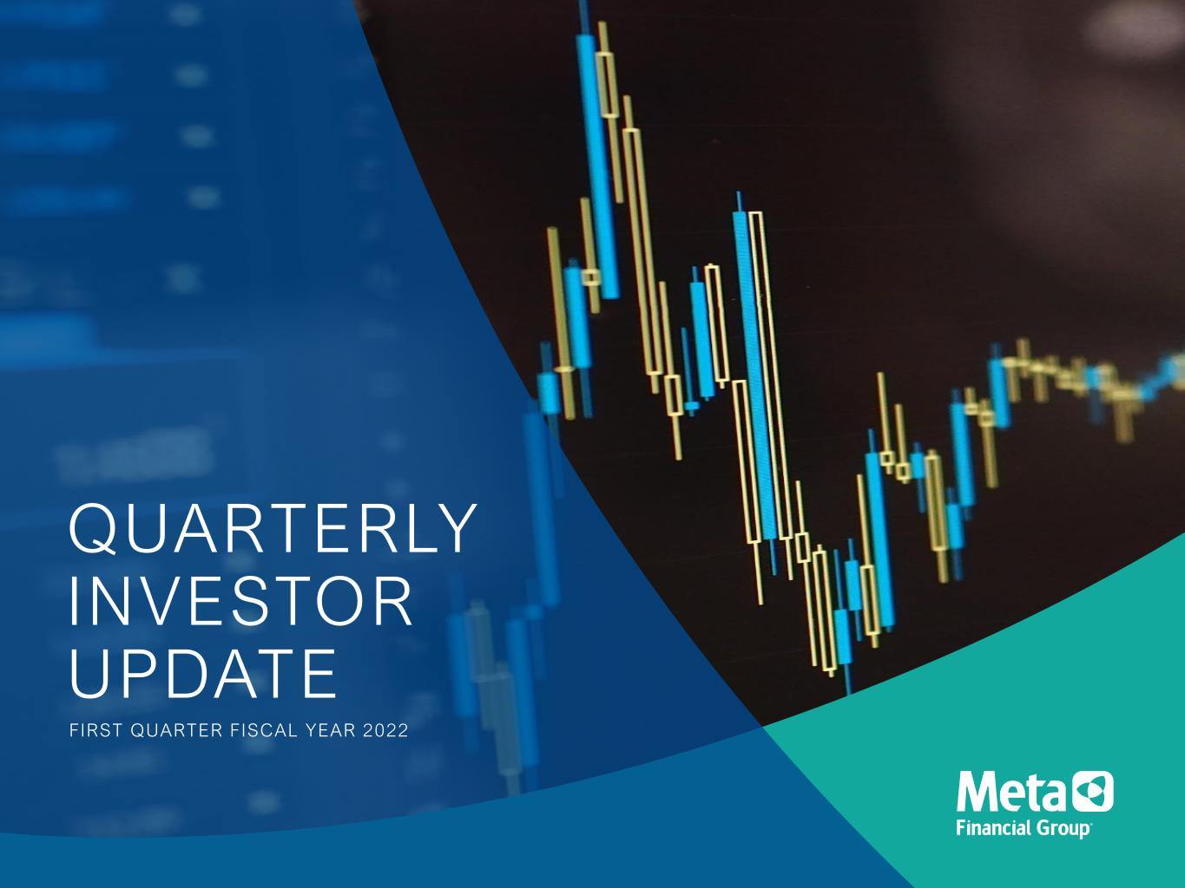
QUARTERLY INVESTOR UPDATE FIRST QUARTER FISCAL YEAR 2022

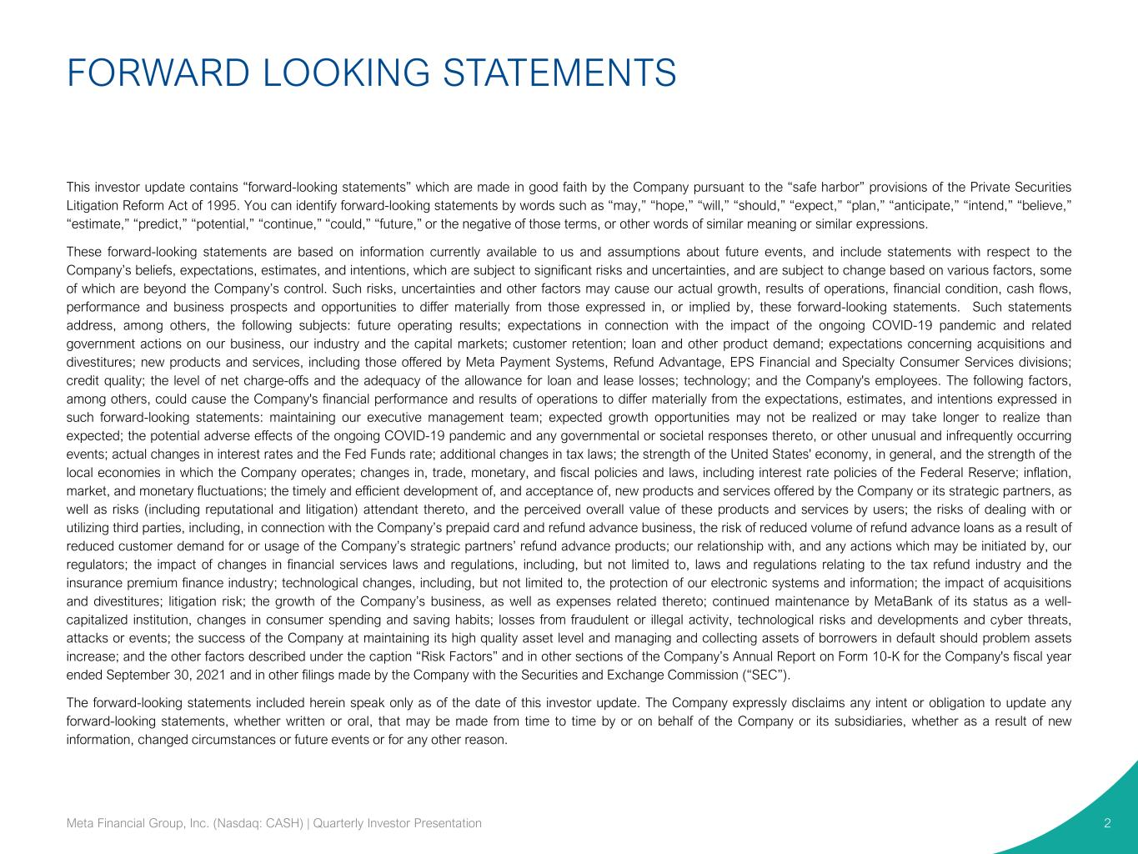
FORWARD LOOKING STATEMENTS 2 This investor update contains “forward-looking statements” which are made in good faith by the Company pursuant to the “safe harbor” provisions of the Private Securities Litigation Reform Act of 1995. You can identify forward-looking statements by words such as “may,” “hope,” “will,” “should,” “expect,” “plan,” “anticipate,” “intend,” “believe,” “estimate,” “predict,” “potential,” “continue,” “could,” “future,” or the negative of those terms, or other words of similar meaning or similar expressions. These forward-looking statements are based on information currently available to us and assumptions about future events, and include statements with respect to the Company’s beliefs, expectations, estimates, and intentions, which are subject to significant risks and uncertainties, and are subject to change based on various factors, some of which are beyond the Company’s control. Such risks, uncertainties and other factors may cause our actual growth, results of operations, financial condition, cash flows, performance and business prospects and opportunities to differ materially from those expressed in, or implied by, these forward-looking statements. Such statements address, among others, the following subjects: future operating results; expectations in connection with the impact of the ongoing COVID-19 pandemic and related government actions on our business, our industry and the capital markets; customer retention; loan and other product demand; expectations concerning acquisitions and divestitures; new products and services, including those offered by Meta Payment Systems, Refund Advantage, EPS Financial and Specialty Consumer Services divisions; credit quality; the level of net charge-offs and the adequacy of the allowance for loan and lease losses; technology; and the Company's employees. The following factors, among others, could cause the Company's financial performance and results of operations to differ materially from the expectations, estimates, and intentions expressed in such forward-looking statements: maintaining our executive management team; expected growth opportunities may not be realized or may take longer to realize than expected; the potential adverse effects of the ongoing COVID-19 pandemic and any governmental or societal responses thereto, or other unusual and infrequently occurring events; actual changes in interest rates and the Fed Funds rate; additional changes in tax laws; the strength of the United States' economy, in general, and the strength of the local economies in which the Company operates; changes in, trade, monetary, and fiscal policies and laws, including interest rate policies of the Federal Reserve; inflation, market, and monetary fluctuations; the timely and efficient development of, and acceptance of, new products and services offered by the Company or its strategic partners, as well as risks (including reputational and litigation) attendant thereto, and the perceived overall value of these products and services by users; the risks of dealing with or utilizing third parties, including, in connection with the Company’s prepaid card and refund advance business, the risk of reduced volume of refund advance loans as a result of reduced customer demand for or usage of the Company’s strategic partners’ refund advance products; our relationship with, and any actions which may be initiated by, our regulators; the impact of changes in financial services laws and regulations, including, but not limited to, laws and regulations relating to the tax refund industry and the insurance premium finance industry; technological changes, including, but not limited to, the protection of our electronic systems and information; the impact of acquisitions and divestitures; litigation risk; the growth of the Company’s business, as well as expenses related thereto; continued maintenance by MetaBank of its status as a well- capitalized institution, changes in consumer spending and saving habits; losses from fraudulent or illegal activity, technological risks and developments and cyber threats, attacks or events; the success of the Company at maintaining its high quality asset level and managing and collecting assets of borrowers in default should problem assets increase; and the other factors described under the caption “Risk Factors” and in other sections of the Company’s Annual Report on Form 10-K for the Company's fiscal year ended September 30, 2021 and in other filings made by the Company with the Securities and Exchange Commission (“SEC”). The forward-looking statements included herein speak only as of the date of this investor update. The Company expressly disclaims any intent or obligation to update any forward-looking statements, whether written or oral, that may be made from time to time by or on behalf of the Company or its subsidiaries, whether as a result of new information, changed circumstances or future events or for any other reason. Meta Financial Group, Inc. (Nasdaq: CASH) | Quarterly Investor Presentation


3 WE STRIVE TO INCREASE FINANCIAL AVAILABILITY, CHOICE, AND OPPORTUNITY THROUGH FINANCIAL EMPOWERMENT. We work to disrupt traditional banking norms by developing partnerships with fintechs, affinity groups, government agencies, and other banks to make a range of quality financial products and services available to the communities we serve nationally. Our national bank charter, coordination with regulators, and deep understanding of risk mitigation and compliance allows us to guide our partners and deliver the financial products and services that meet the needs of those who need them most. We believe in financial inclusion for all®. Meta Financial Group, Inc. (Nasdaq: CASH) | Quarterly Investor Presentation

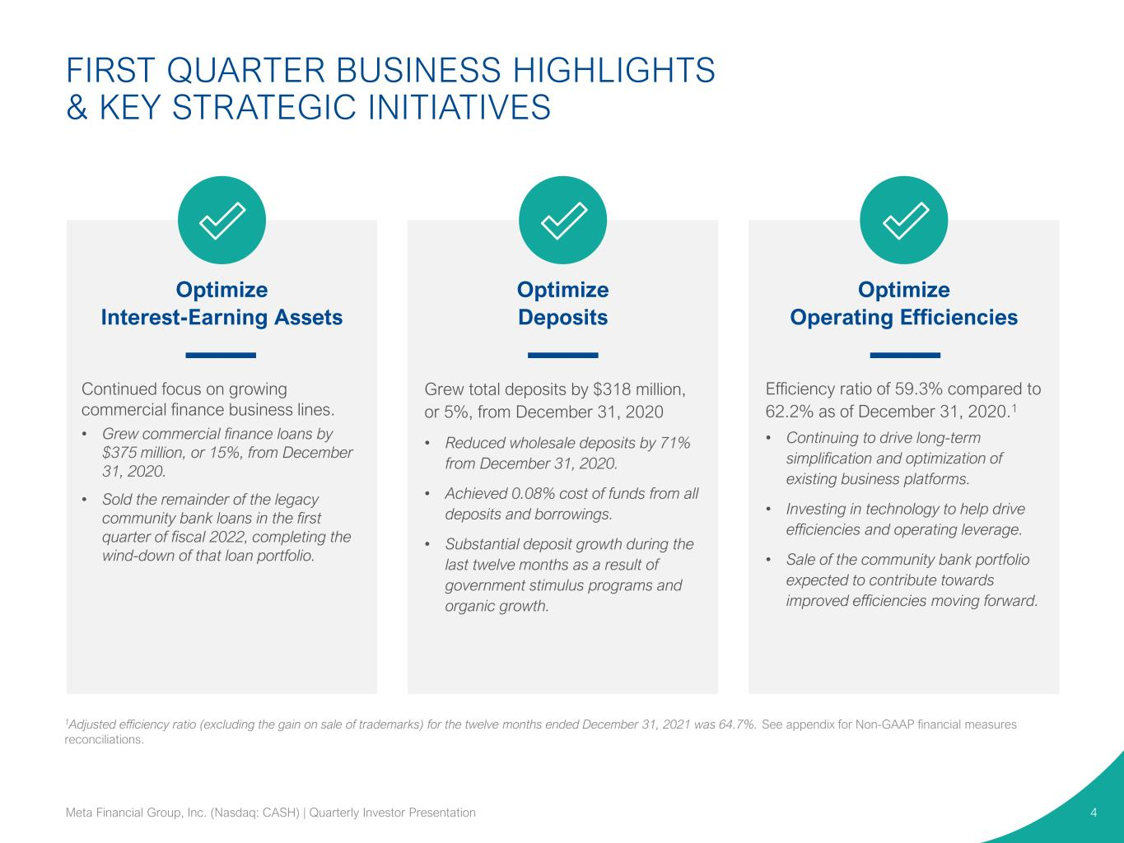
Optimize Interest-Earning Assets Optimize Deposits Optimize Operating Efficiencies Efficiency ratio of 59.3% compared to 62.2% as of December 31, 2020.1 • Continuing to drive long-term simplification and optimization of existing business platforms. • Investing in technology to help drive efficiencies and operating leverage. • Sale of the community bank portfolio expected to contribute towards improved efficiencies moving forward. Grew total deposits by $318 million, or 5%, from December 31, 2020 • Reduced wholesale deposits by 71% from December 31, 2020. • Achieved 0.08% cost of funds from all deposits and borrowings. • Substantial deposit growth during the last twelve months as a result of government stimulus programs and organic growth. Continued focus on growing commercial finance business lines. • Grew commercial finance loans by $375 million, or 15%, from December 31, 2020. • Sold the remainder of the legacy community bank loans in the first quarter of fiscal 2022, completing the wind-down of that loan portfolio. FIRST QUARTER BUSINESS HIGHLIGHTS & KEY STRATEGIC INITIATIVES 4Meta Financial Group, Inc. (Nasdaq: CASH) | Quarterly Investor Presentation 1Adjusted efficiency ratio (excluding the gain on sale of trademarks) for the twelve months ended December 31, 2021 was 64.7%. See appendix for Non-GAAP financial measures reconciliations.

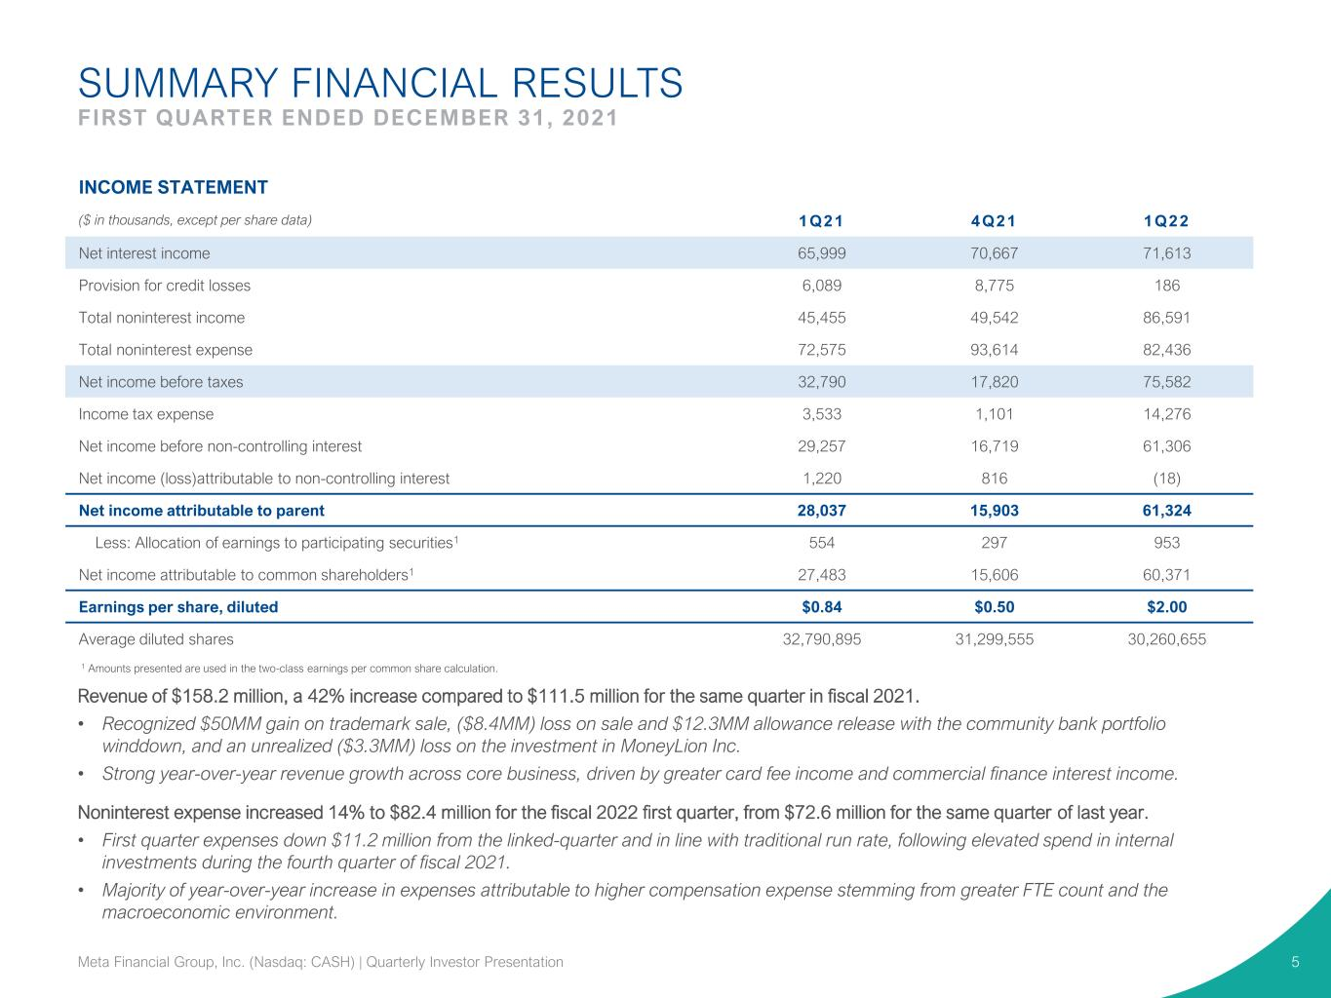
SUMMARY FINANCIAL RESULTS FIRST QUARTER ENDED DECEMBER 31, 2021 5 1 Amounts presented are used in the two-class earnings per common share calculation. INCOME STATEMENT ($ in thousands, except per share data) 1Q21 4Q21 1Q22 Net interest income 65,999 70,667 71,613 Provision for credit losses 6,089 8,775 186 Total noninterest income 45,455 49,542 86,591 Total noninterest expense 72,575 93,614 82,436 Net income before taxes 32,790 17,820 75,582 Income tax expense 3,533 1,101 14,276 Net income before non-controlling interest 29,257 16,719 61,306 Net income (loss)attributable to non-controlling interest 1,220 816 (18) Net income attributable to parent 28,037 15,903 61,324 Less: Allocation of earnings to participating securities1 554 297 953 Net income attributable to common shareholders1 27,483 15,606 60,371 Earnings per share, diluted $0.84 $0.50 $2.00 Average diluted shares 32,790,895 31,299,555 30,260,655 Revenue of $158.2 million, a 42% increase compared to $111.5 million for the same quarter in fiscal 2021. • Recognized $50MM gain on trademark sale, ($8.4MM) loss on sale and $12.3MM allowance release with the community bank portfolio winddown, and an unrealized ($3.3MM) loss on the investment in MoneyLion Inc. • Strong year-over-year revenue growth across core business, driven by greater card fee income and commercial finance interest income. Noninterest expense increased 14% to $82.4 million for the fiscal 2022 first quarter, from $72.6 million for the same quarter of last year. • First quarter expenses down $11.2 million from the linked-quarter and in line with traditional run rate, following elevated spend in internal investments during the fourth quarter of fiscal 2021. • Majority of year-over-year increase in expenses attributable to higher compensation expense stemming from greater FTE count and the macroeconomic environment. Meta Financial Group, Inc. (Nasdaq: CASH) | Quarterly Investor Presentation

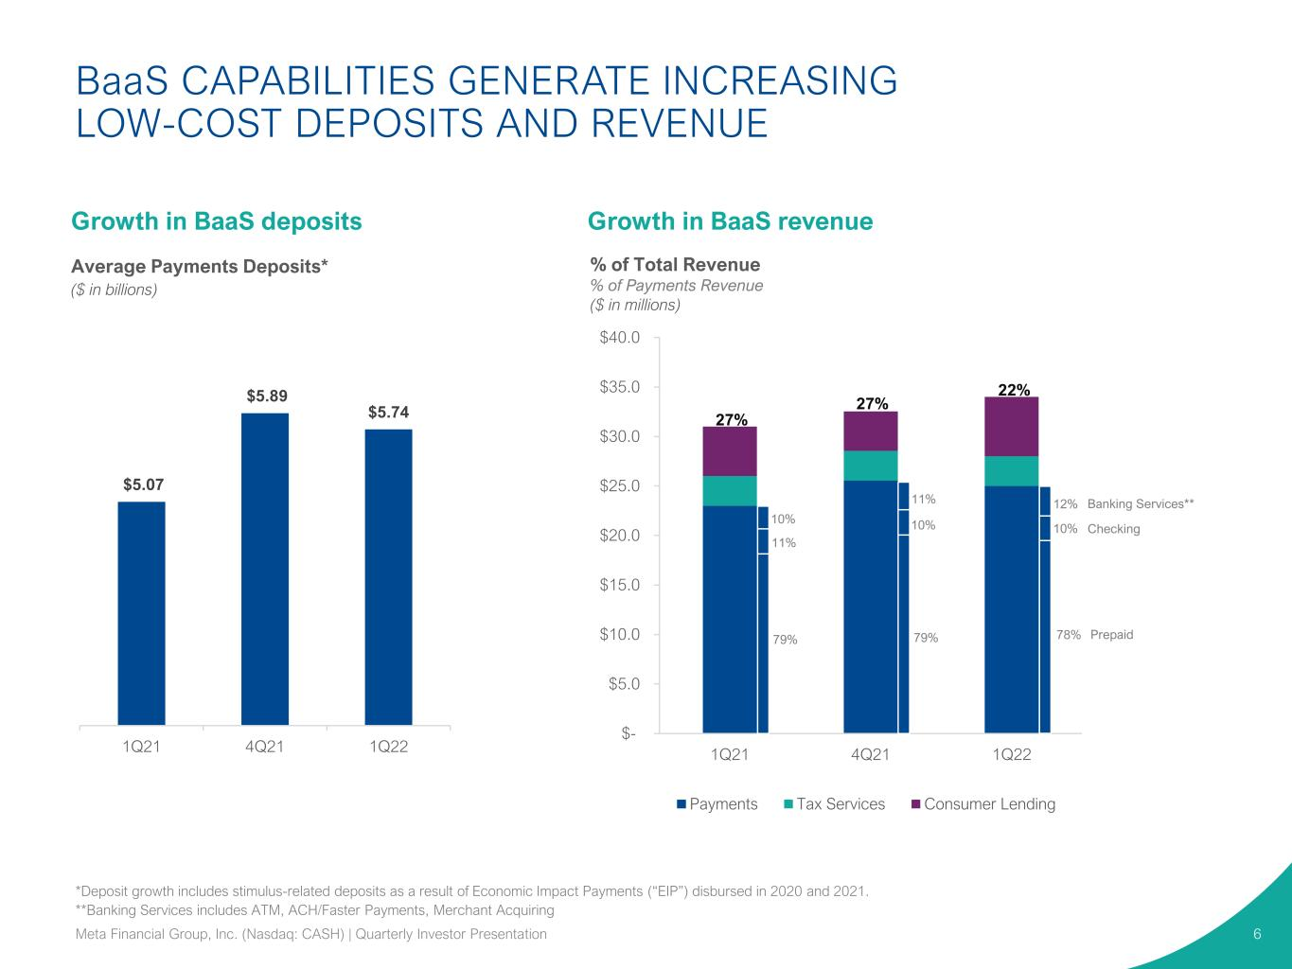
$- $5.0 $10.0 $15.0 $20.0 $25.0 $30.0 $35.0 $40.0 1Q21 4Q21 1Q22 Payments Tax Services Consumer Lending BaaS CAPABILITIES GENERATE INCREASING LOW-COST DEPOSITS AND REVENUE 6 Growth in BaaS revenue Average Payments Deposits* ($ in billions) 27% 27% 22% % of Total Revenue % of Payments Revenue ($ in millions) $5.07 $5.89 $5.74 1Q21 4Q21 1Q22 *Deposit growth includes stimulus-related deposits as a result of Economic Impact Payments (“EIP”) disbursed in 2020 and 2021. **Banking Services includes ATM, ACH/Faster Payments, Merchant Acquiring Growth in BaaS deposits Banking Services** Checking Prepaid 12% 10% 78% Meta Financial Group, Inc. (Nasdaq: CASH) | Quarterly Investor Presentation 10% 11% 79% 11% 10% 79%

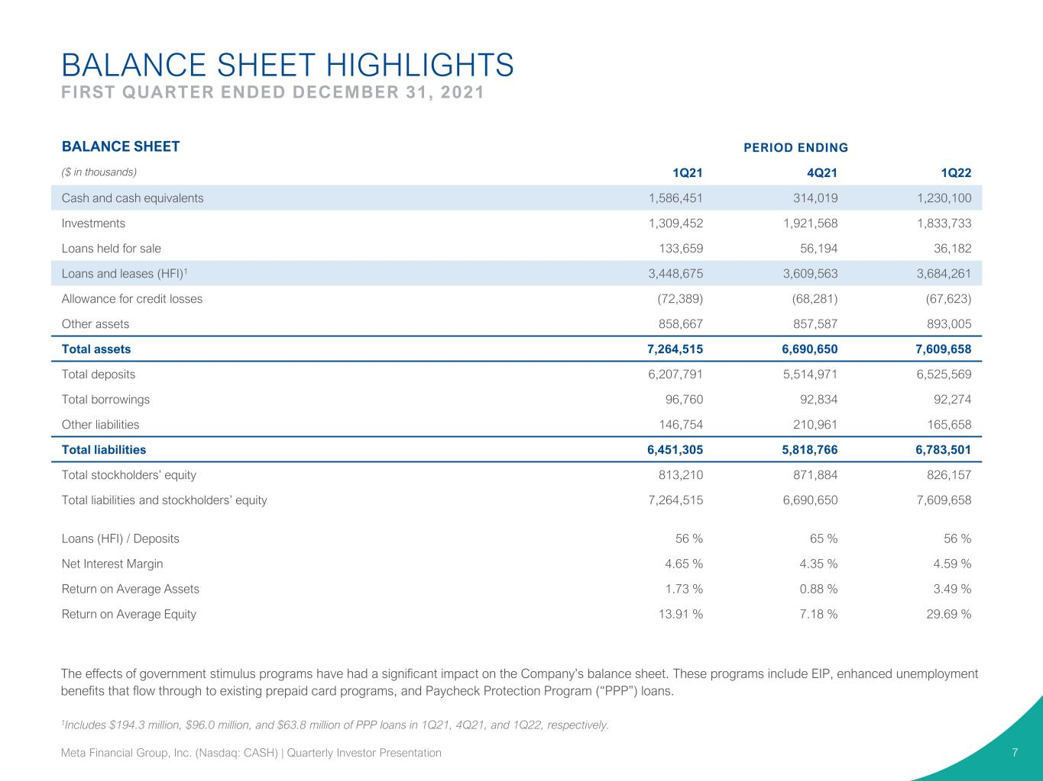
BALANCE SHEET HIGHLIGHTS FIRST QUARTER ENDED DECEMBER 31, 2021 7 BALANCE SHEET PERIOD ENDING ($ in thousands) 1Q21 4Q21 1Q22 Cash and cash equivalents 1,586,451 314,019 1,230,100 Investments 1,309,452 1,921,568 1,833,733 Loans held for sale 133,659 56,194 36,182 Loans and leases (HFI)1 3,448,675 3,609,563 3,684,261 Allowance for credit losses (72,389) (68,281) (67,623) Other assets 858,667 857,587 893,005 Total assets 7,264,515 6,690,650 7,609,658 Total deposits 6,207,791 5,514,971 6,525,569 Total borrowings 96,760 92,834 92,274 Other liabilities 146,754 210,961 165,658 Total liabilities 6,451,305 5,818,766 6,783,501 Total stockholders’ equity 813,210 871,884 826,157 Total liabilities and stockholders’ equity 7,264,515 6,690,650 7,609,658 Loans (HFI) / Deposits 56 % 65 % 56 % Net Interest Margin 4.65 % 4.35 % 4.59 % Return on Average Assets 1.73 % 0.88 % 3.49 % Return on Average Equity 13.91 % 7.18 % 29.69 % 1Includes $194.3 million, $96.0 million, and $63.8 million of PPP loans in 1Q21, 4Q21, and 1Q22, respectively. The effects of government stimulus programs have had a significant impact on the Company’s balance sheet. These programs include EIP, enhanced unemployment benefits that flow through to existing prepaid card programs, and Paycheck Protection Program (“PPP”) loans. Meta Financial Group, Inc. (Nasdaq: CASH) | Quarterly Investor Presentation

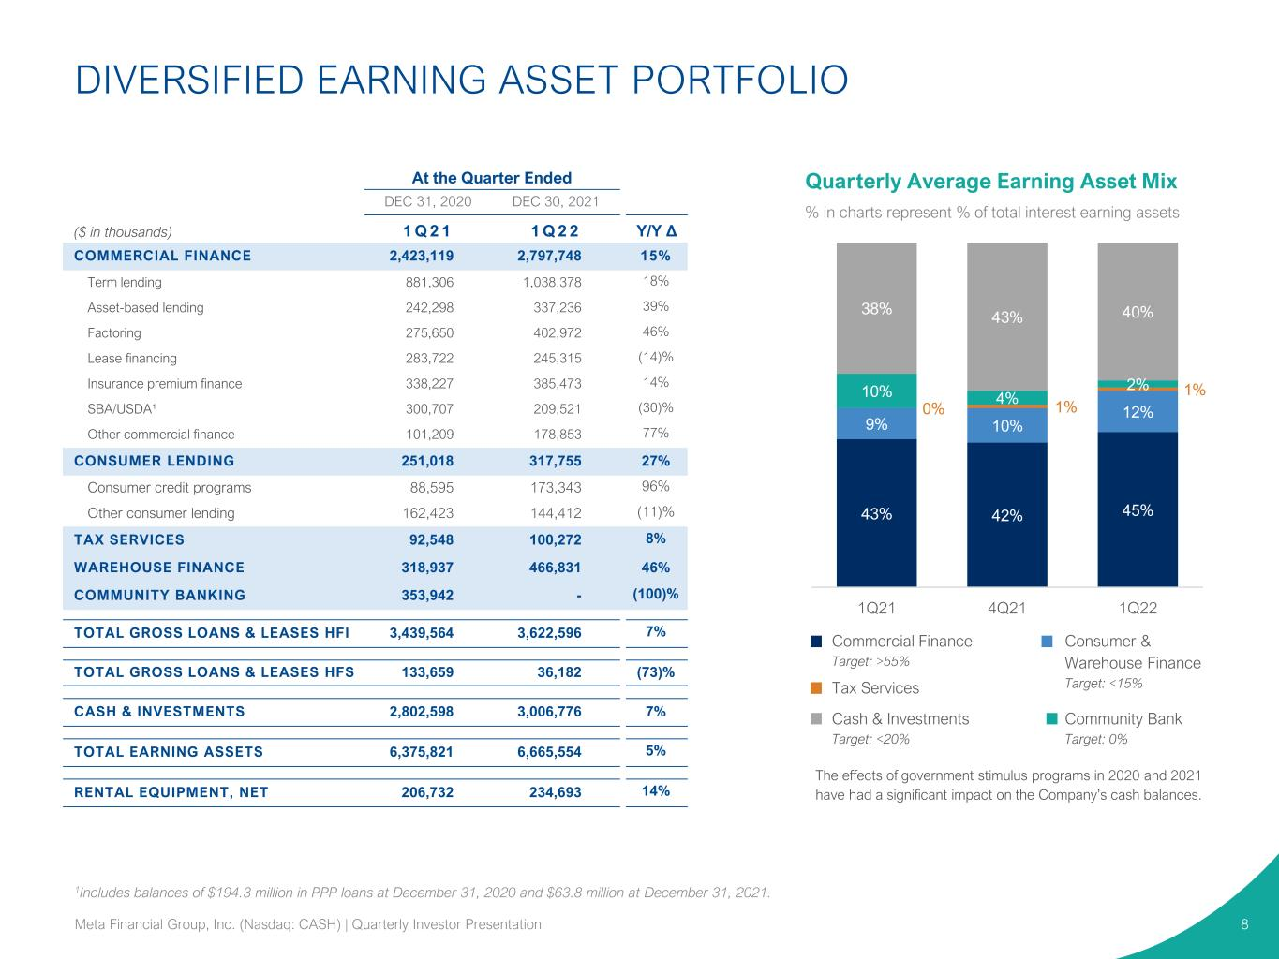
Quarterly Average Earning Asset Mix % in charts represent % of total interest earning assets At the Quarter Ended DEC 31, 2020 DEC 30, 2021 ($ in thousands) 1 Q 2 1 1 Q 2 2 Y/Y Δ COMMERCIAL FINANCE 2,423,119 2,797,748 15% Term lending 881,306 1,038,378 18% Asset-based lending 242,298 337,236 39% Factoring 275,650 402,972 46% Lease financing 283,722 245,315 (14)% Insurance premium finance 338,227 385,473 14% SBA/USDA¹ 300,707 209,521 (30)% Other commercial finance 101,209 178,853 77% CONSUMER LENDING 251,018 317,755 27% Consumer credit programs 88,595 173,343 96% Other consumer lending 162,423 144,412 (11)% TAX SERVICES 92,548 100,272 8% WAREHOUSE FINANCE 318,937 466,831 46% COMMUNITY BANKING 353,942 - (100)% TOTAL GROSS LOANS & LEASES HFI 3,439,564 3,622,596 7% TOTAL GROSS LOANS & LEASES HFS 133,659 36,182 (73)% CASH & INVESTMENTS 2,802,598 3,006,776 7% TOTAL EARNING ASSETS 6,375,821 6,665,554 5% RENTAL EQUIPMENT, NET 206,732 234,693 14% 1Includes balances of $194.3 million in PPP loans at December 31, 2020 and $63.8 million at December 31, 2021. DIVERSIFIED EARNING ASSET PORTFOLIO 8 43% 42% 45% 9% 10% 12%0% 1% 1%10% 4% 2% 38% 43% 40% 1Q21 4Q21 1Q22 Commercial Finance Target: >55% Consumer & Warehouse Finance Target: <15%Tax Services Community Bank Target: 0% Cash & Investments Target: <20% The effects of government stimulus programs in 2020 and 2021 have had a significant impact on the Company’s cash balances. Meta Financial Group, Inc. (Nasdaq: CASH) | Quarterly Investor Presentation

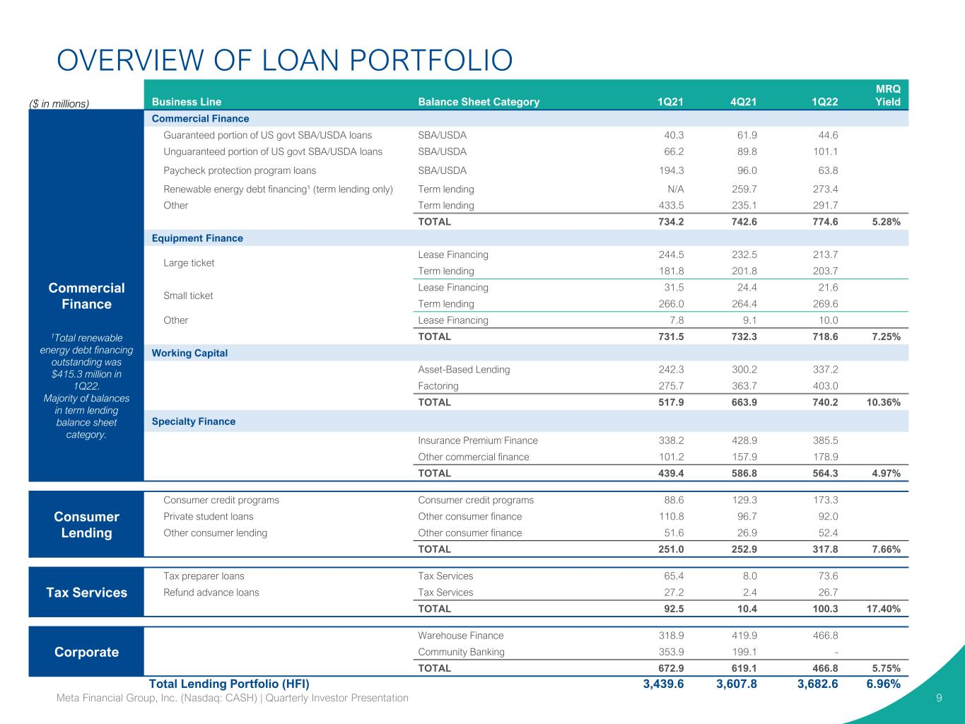
OVERVIEW OF LOAN PORTFOLIO 9 ($ in millions) Business Line Balance Sheet Category 1Q21 4Q21 1Q22 MRQ Yield Commercial Finance Commercial Finance Guaranteed portion of US govt SBA/USDA loans SBA/USDA 40.3 61.9 44.6 Unguaranteed portion of US govt SBA/USDA loans SBA/USDA 66.2 89.8 101.1 Paycheck protection program loans SBA/USDA 194.3 96.0 63.8 Renewable energy debt financing¹ (term lending only) Term lending N/A 259.7 273.4 Other Term lending 433.5 235.1 291.7 TOTAL 734.2 742.6 774.6 5.28% Equipment Finance Large ticket Lease Financing 244.5 232.5 213.7 Term lending 181.8 201.8 203.7 Small ticket Lease Financing 31.5 24.4 21.6 Term lending 266.0 264.4 269.6 Other Lease Financing 7.8 9.1 10.0 TOTAL 731.5 732.3 718.6 7.25% Working Capital Asset-Based Lending 242.3 300.2 337.2 Factoring 275.7 363.7 403.0 TOTAL 517.9 663.9 740.2 10.36% Specialty Finance Insurance Premium Finance 338.2 428.9 385.5 Other commercial finance 101.2 157.9 178.9 TOTAL 439.4 586.8 564.3 4.97% Consumer Lending Consumer credit programs Consumer credit programs 88.6 129.3 173.3 Private student loans Other consumer finance 110.8 96.7 92.0 Other consumer lending Other consumer finance 51.6 26.9 52.4 TOTAL 251.0 252.9 317.8 7.66% Tax Services Tax preparer loans Tax Services 65.4 8.0 73.6 Refund advance loans Tax Services 27.2 2.4 26.7 TOTAL 92.5 10.4 100.3 17.40% Corporate Warehouse Finance 318.9 419.9 466.8 Community Banking 353.9 199.1 - TOTAL 672.9 619.1 466.8 5.75% Total Lending Portfolio (HFI) 3,439.6 3,607.8 3,682.6 6.96% Meta Financial Group, Inc. (Nasdaq: CASH) | Quarterly Investor Presentation 1Total renewable energy debt financing outstanding was $415.3 million in 1Q22. Majority of balances in term lending balance sheet category.

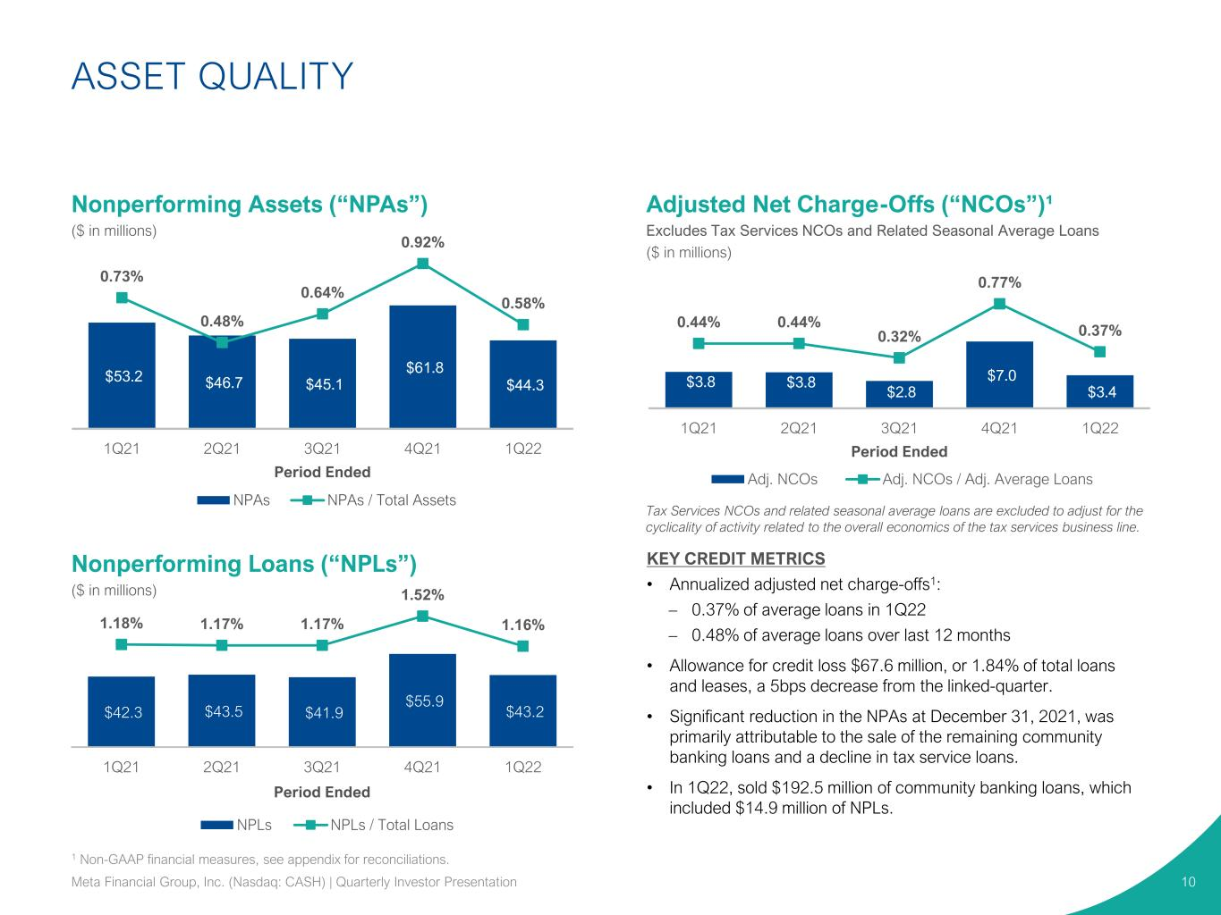
$3.8 $3.8 $2.8 $7.0 $3.4 0.44% 0.44% 0.32% 0.77% 0.37% 1Q21 2Q21 3Q21 4Q21 1Q22 Period Ended Adj. NCOs Adj. NCOs / Adj. Average Loans Adjusted Net Charge-Offs (“NCOs”)¹ Excludes Tax Services NCOs and Related Seasonal Average Loans ($ in millions) KEY CREDIT METRICS • Annualized adjusted net charge-offs1: – 0.37% of average loans in 1Q22 – 0.48% of average loans over last 12 months • Allowance for credit loss $67.6 million, or 1.84% of total loans and leases, a 5bps decrease from the linked-quarter. • Significant reduction in the NPAs at December 31, 2021, was primarily attributable to the sale of the remaining community banking loans and a decline in tax service loans. • In 1Q22, sold $192.5 million of community banking loans, which included $14.9 million of NPLs. $53.2 $46.7 $45.1 $61.8 $44.3 0.73% 0.48% 0.64% 0.92% 0.58% 1Q21 2Q21 3Q21 4Q21 1Q22 Period Ended NPAs NPAs / Total Assets ASSET QUALITY 10 1 Non-GAAP financial measures, see appendix for reconciliations. Tax Services NCOs and related seasonal average loans are excluded to adjust for the cyclicality of activity related to the overall economics of the tax services business line. $42.3 $43.5 $41.9 $55.9 $43.2 1.18% 1.17% 1.17% 1.52% 1.16% 1Q21 2Q21 3Q21 4Q21 1Q22 Period Ended NPLs NPLs / Total Loans Nonperforming Assets (“NPAs”) ($ in millions) Nonperforming Loans (“NPLs”) ($ in millions) Meta Financial Group, Inc. (Nasdaq: CASH) | Quarterly Investor Presentation

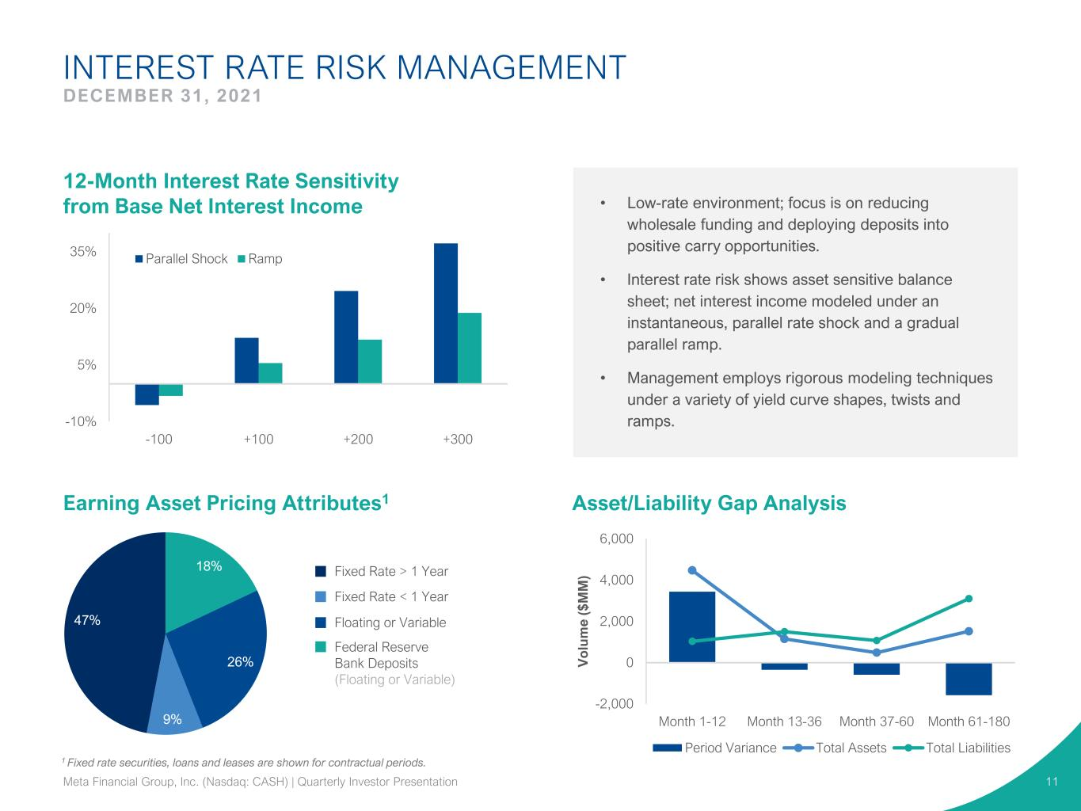
-10% 5% 20% 35% -100 +100 +200 +300 Parallel Shock Ramp 1 Fixed rate securities, loans and leases are shown for contractual periods. -2,000 0 2,000 4,000 6,000 Month 1-12 Month 13-36 Month 37-60 Month 61-180 V o lu m e ( $ M M ) Period Variance Total Assets Total Liabilities INTEREST RATE RISK MANAGEMENT DECEMBER 31, 2021 11 18% 26% 9% 47% • Low-rate environment; focus is on reducing wholesale funding and deploying deposits into positive carry opportunities. • Interest rate risk shows asset sensitive balance sheet; net interest income modeled under an instantaneous, parallel rate shock and a gradual parallel ramp. • Management employs rigorous modeling techniques under a variety of yield curve shapes, twists and ramps. Fixed Rate > 1 Year 12-Month Interest Rate Sensitivity from Base Net Interest Income Earning Asset Pricing Attributes1 Asset/Liability Gap Analysis Fixed Rate < 1 Year Floating or Variable Federal Reserve Bank Deposits (Floating or Variable) Meta Financial Group, Inc. (Nasdaq: CASH) | Quarterly Investor Presentation

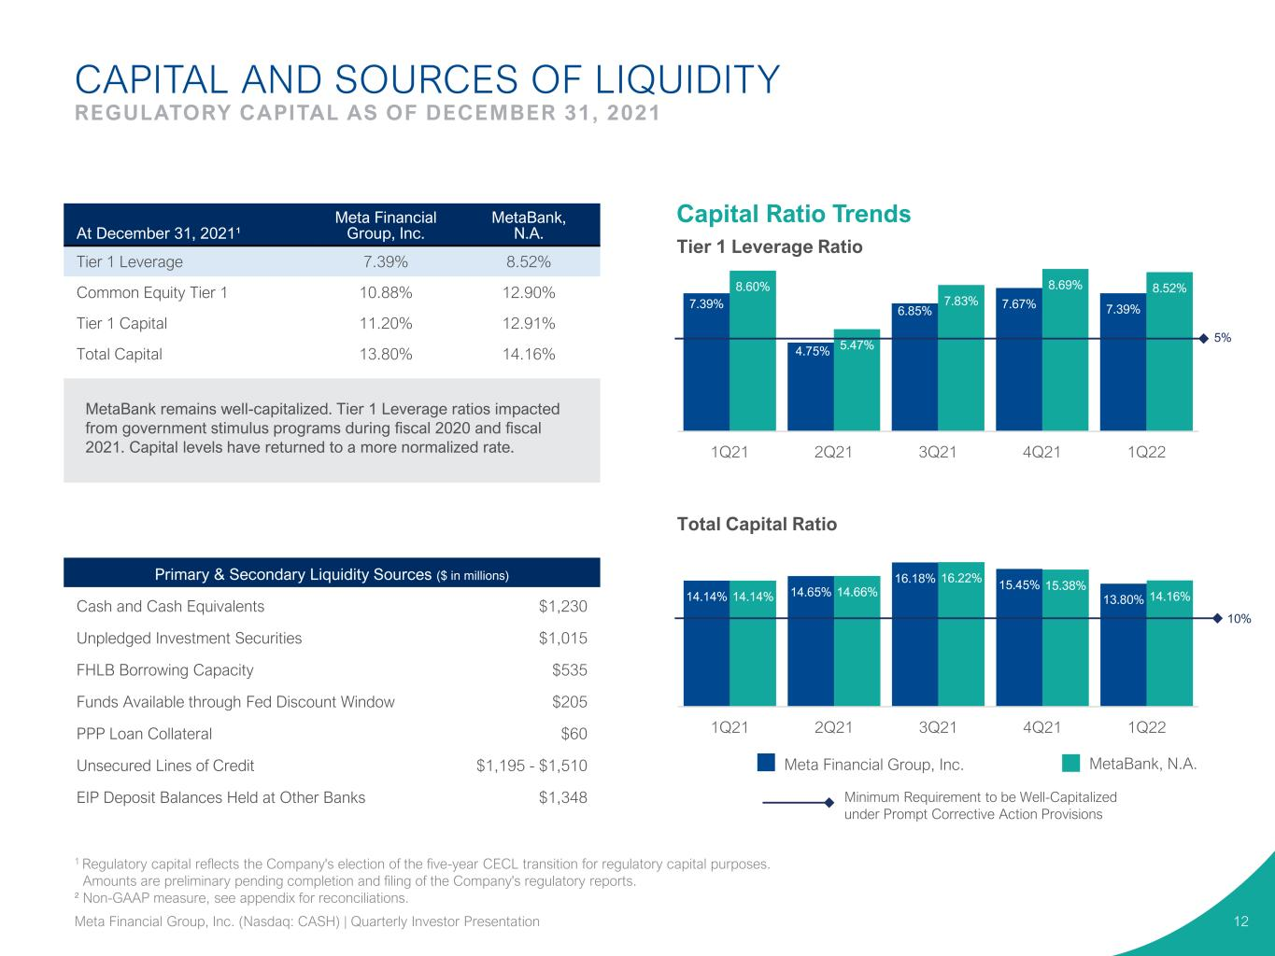
7.39% 4.75% 6.85% 7.67% 7.39% 8.60% 5.47% 7.83% 8.69% 8.52% 1Q21 2Q21 3Q21 4Q21 1Q22 CAPITAL AND SOURCES OF LIQUIDITY REGULATORY CAPITAL AS OF DECEMBER 31, 2021 Minimum Requirement to be Well-Capitalized under Prompt Corrective Action Provisions Meta Financial Group, Inc. MetaBank, N.A. Capital Ratio Trends At December 31, 2021¹ Meta Financial Group, Inc. MetaBank, N.A. Tier 1 Leverage 7.39% 8.52% Common Equity Tier 1 10.88% 12.90% Tier 1 Capital 11.20% 12.91% Total Capital 13.80% 14.16% MetaBank remains well-capitalized. Tier 1 Leverage ratios impacted from government stimulus programs during fiscal 2020 and fiscal 2021. Capital levels have returned to a more normalized rate. Primary & Secondary Liquidity Sources ($ in millions) Cash and Cash Equivalents $1,230 Unpledged Investment Securities $1,015 FHLB Borrowing Capacity $535 Funds Available through Fed Discount Window $205 PPP Loan Collateral $60 Unsecured Lines of Credit $1,195 - $1,510 EIP Deposit Balances Held at Other Banks $1,348 14.14% 14.65% 16.18% 15.45% 13.80%14.14% 14.66% 16.22% 15.38% 14.16% 1Q21 2Q21 3Q21 4Q21 1Q22 10% 5% 12 Total Capital Ratio Tier 1 Leverage Ratio 1 Regulatory capital reflects the Company's election of the five-year CECL transition for regulatory capital purposes. Amounts are preliminary pending completion and filing of the Company's regulatory reports. ² Non-GAAP measure, see appendix for reconciliations. Meta Financial Group, Inc. (Nasdaq: CASH) | Quarterly Investor Presentation

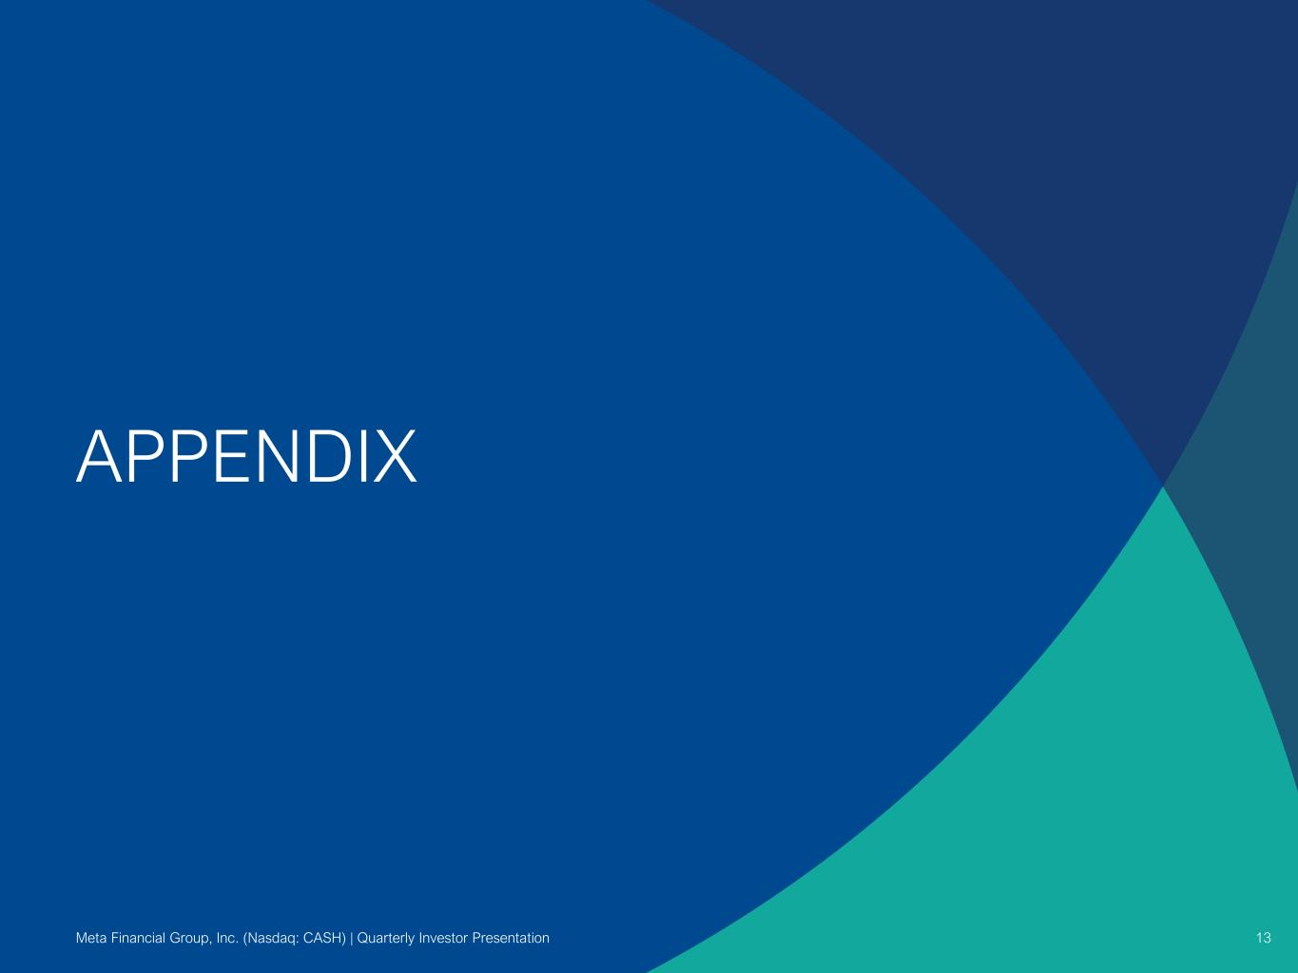
APPENDIX 13Meta Financial Group, Inc. (Nasdaq: CASH) | Quarterly Investor Presentation

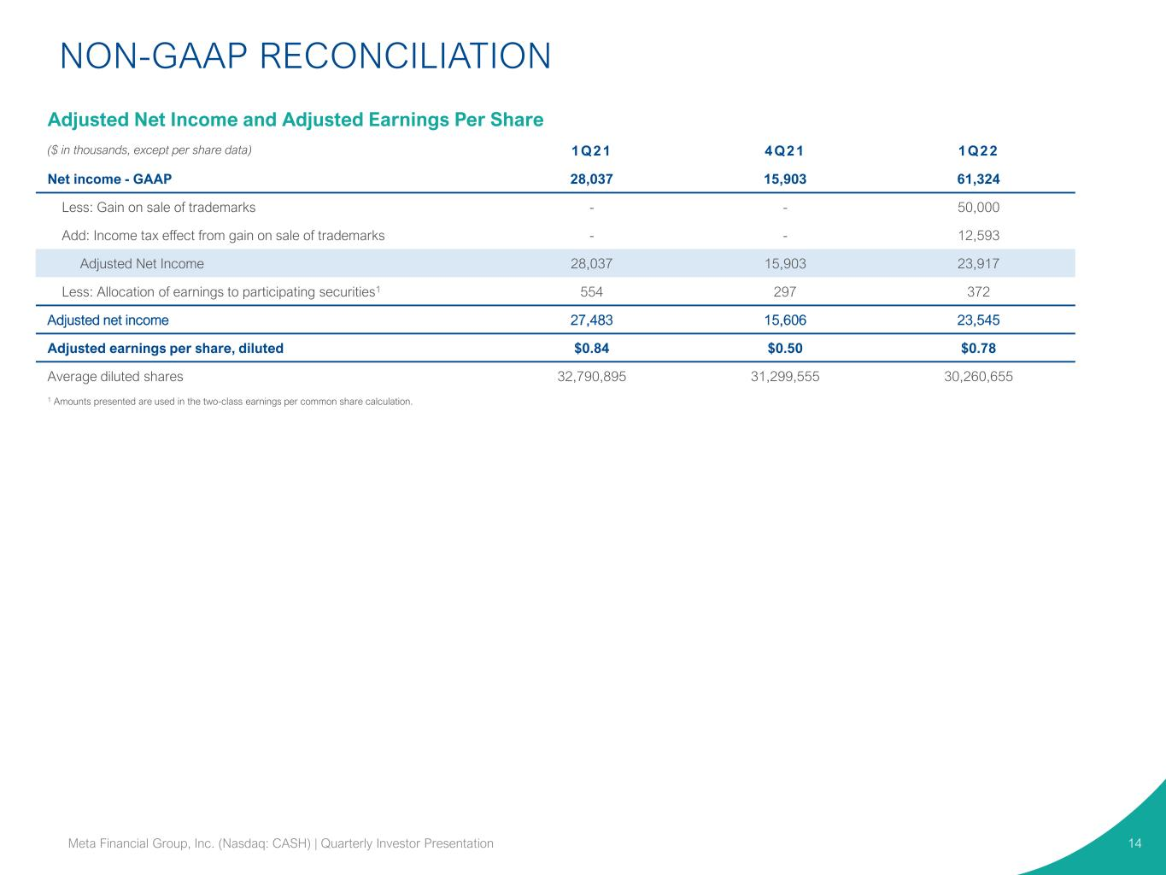
NON-GAAP RECONCILIATION 14Meta Financial Group, Inc. (Nasdaq: CASH) | Quarterly Investor Presentation Adjusted Net Income and Adjusted Earnings Per Share ($ in thousands, except per share data) 1Q21 4Q21 1Q22 Net income - GAAP 28,037 15,903 61,324 Less: Gain on sale of trademarks - - 50,000 Add: Income tax effect from gain on sale of trademarks - - 12,593 Adjusted Net Income 28,037 15,903 23,917 Less: Allocation of earnings to participating securities1 554 297 372 Adjusted net income 27,483 15,606 23,545 Adjusted earnings per share, diluted $0.84 $0.50 $0.78 Average diluted shares 32,790,895 31,299,555 30,260,655 1 Amounts presented are used in the two-class earnings per common share calculation.

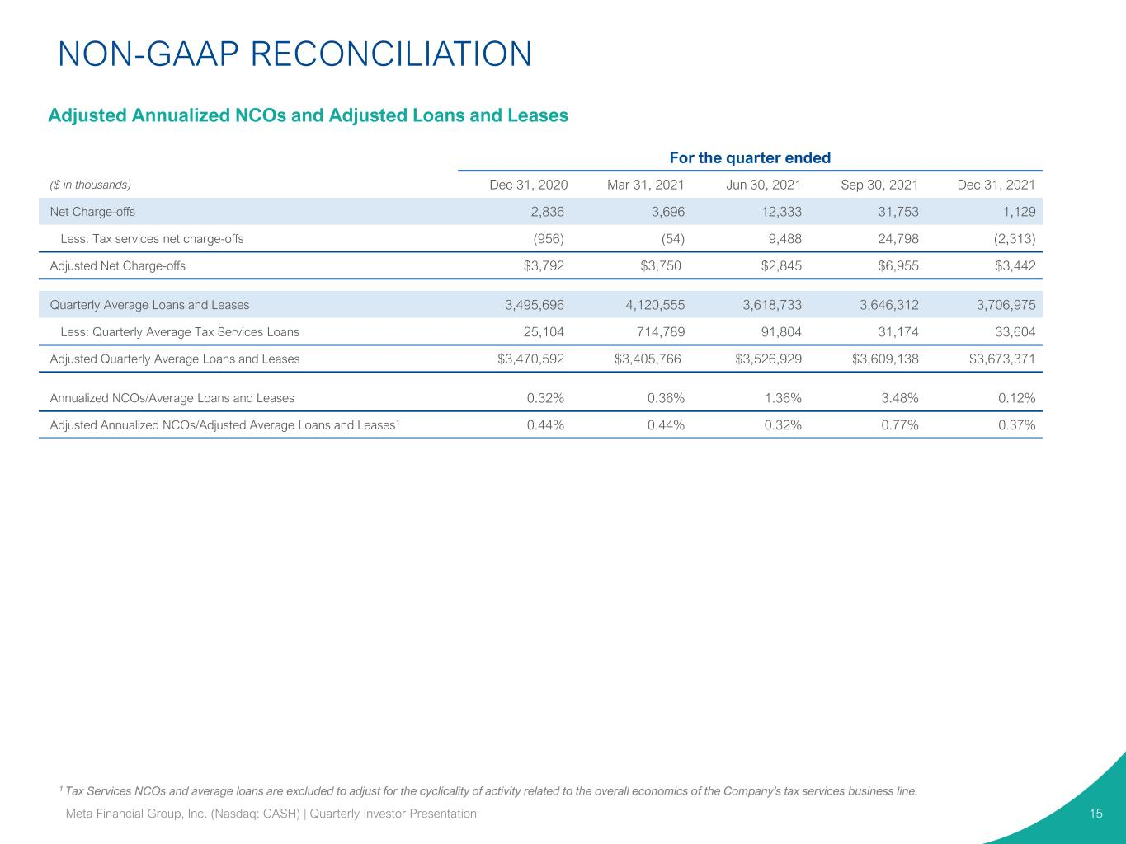
1 Tax Services NCOs and average loans are excluded to adjust for the cyclicality of activity related to the overall economics of the Company's tax services business line. 15 For the quarter ended ($ in thousands) Dec 31, 2020 Mar 31, 2021 Jun 30, 2021 Sep 30, 2021 Dec 31, 2021 Net Charge-offs 2,836 3,696 12,333 31,753 1,129 Less: Tax services net charge-offs (956) (54) 9,488 24,798 (2,313) Adjusted Net Charge-offs $3,792 $3,750 $2,845 $6,955 $3,442 Quarterly Average Loans and Leases 3,495,696 4,120,555 3,618,733 3,646,312 3,706,975 Less: Quarterly Average Tax Services Loans 25,104 714,789 91,804 31,174 33,604 Adjusted Quarterly Average Loans and Leases $3,470,592 $3,405,766 $3,526,929 $3,609,138 $3,673,371 Annualized NCOs/Average Loans and Leases 0.32% 0.36% 1.36% 3.48% 0.12% Adjusted Annualized NCOs/Adjusted Average Loans and Leases1 0.44% 0.44% 0.32% 0.77% 0.37% Meta Financial Group, Inc. (Nasdaq: CASH) | Quarterly Investor Presentation NON-GAAP RECONCILIATION Adjusted Annualized NCOs and Adjusted Loans and Leases

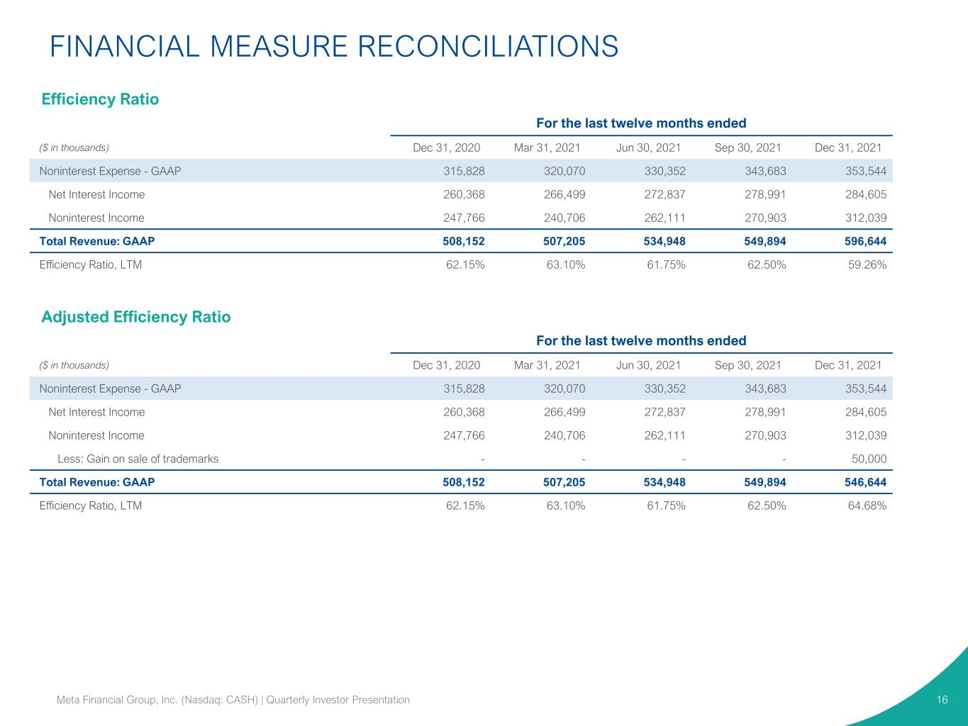
FINANCIAL MEASURE RECONCILIATIONS 16Meta Financial Group, Inc. (Nasdaq: CASH) | Quarterly Investor Presentation For the last twelve months ended ($ in thousands) Dec 31, 2020 Mar 31, 2021 Jun 30, 2021 Sep 30, 2021 Dec 31, 2021 Noninterest Expense - GAAP 315,828 320,070 330,352 343,683 353,544 Net Interest Income 260,368 266,499 272,837 278,991 284,605 Noninterest Income 247,766 240,706 262,111 270,903 312,039 Total Revenue: GAAP 508,152 507,205 534,948 549,894 596,644 Efficiency Ratio, LTM 62.15% 63.10% 61.75% 62.50% 59.26% For the last twelve months ended ($ in thousands) Dec 31, 2020 Mar 31, 2021 Jun 30, 2021 Sep 30, 2021 Dec 31, 2021 Noninterest Expense - GAAP 315,828 320,070 330,352 343,683 353,544 Net Interest Income 260,368 266,499 272,837 278,991 284,605 Noninterest Income 247,766 240,706 262,111 270,903 312,039 Less: Gain on sale of trademarks - - - - 50,000 Total Revenue: GAAP 508,152 507,205 534,948 549,894 546,644 Efficiency Ratio, LTM 62.15% 63.10% 61.75% 62.50% 64.68% Efficiency Ratio Adjusted Efficiency Ratio

